NEDSS Training Exercises for
Module 3: Add a Tuberculosis (RVCT 2020) Investigation

Overview:
- This module contains 1 exercise, #3, with 2 parts.
- When you have finished, email your training lead your responses.

Exercise #3 Instructions
Part 1:
Now that we have gone through creating a patient file and creating a new TB investigation, you will now create your own from start to finish.
Instead of a person’s name, use a 2-word object, i.e., Milk Carton or Table Lamp for example for the patient’s name.
  - What is the name you will use? (look up to see if they entered the patient correctly)
Now, search and create your person. Enter a made-up date of birth and address. Use Austin, Texas as the city, and Travis County as the county.
Enter all other information using drop down boxes for your fictional data.
Hit “Submit” when all the demographics are entered. You should now be in the Patient File.
Next, you will create their Tuberculosis (2020 RVCT) Investigation.
  - In the patient file, what button do you select to create their new Investigation (HINT: look in the “Events” tab).

Add New under “Investigation”

  - Once you have created your patient and started their TB Investigation, please provide a screen shot successfully showing the new TB Investigation – ensure the screen shot includes your patient name and is opened on the Summary tab of the patients file (hint – the TB investigation should show “Tuberculosis (2020 RVCT) as the newly added condition with the date the investigation was added).
Answer to 3 is a screenshot:

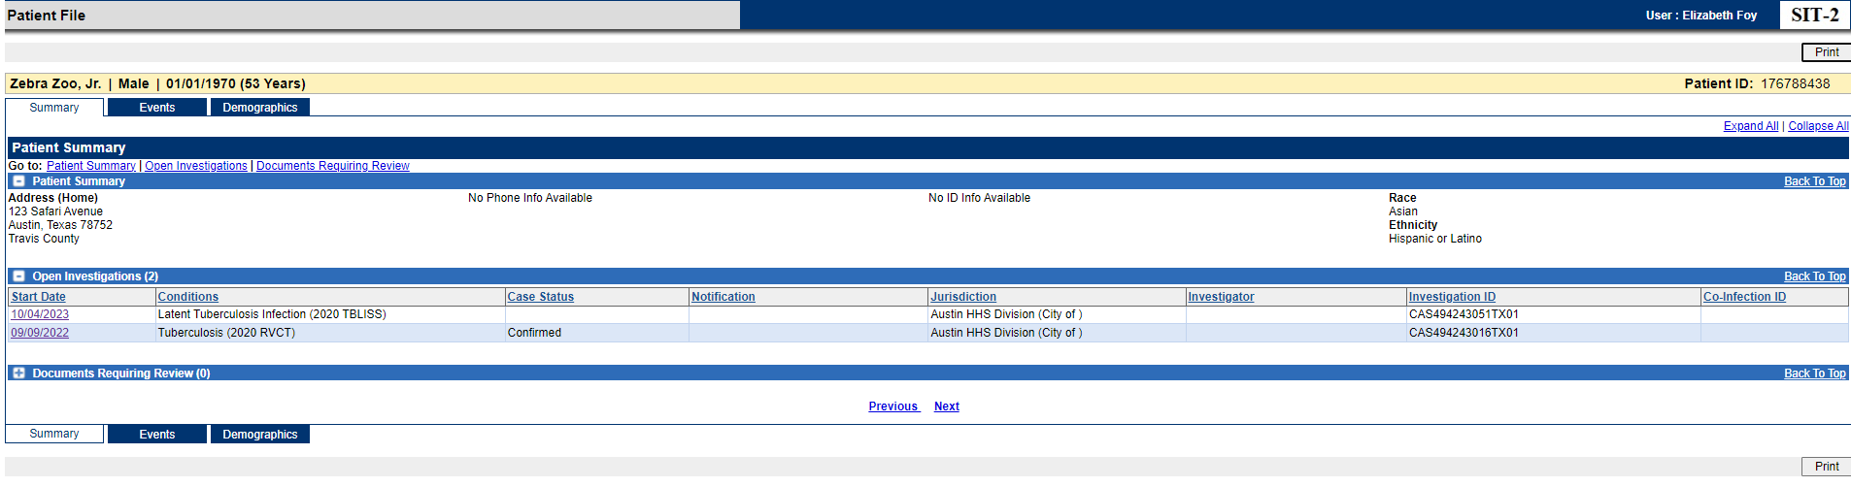

Make sure you see the patient file and that they have the summary page open showing the open investigation of “Tuberculosis (2020 RVCT)”

Part 2:

Part 2:
4). List 3 things you learned about creating a TB Investigation:

- In the Tuberculosis (2020 RVCT) investigation page, how many tabs are there?

- 7
- 12
- 11

- Which tab contains questions that are all greyed-out and not editable when entering data on a Tuberculosis (2020 RVCT) investigation?
LTBI Only

