NEDSS Training Exercises for
Module 10: Contact Records Tab

Overview:
- This module contains one exercise, #14, with two parts.
- When you have finished, email your supervisor your responses.

Exercise #14 Instructions:
Part 1: Creating a contact record
- Create a new patient (person A) and TB or LTBI investigation for that patient. What is the investigation ID?

24384251 (example) – check in the training environment.

- Open another existing patient who has a TB (RVCT 2020) investigation (person B). You will be entering in the Contact Record tab to create a contact record. Select the correct mode to be in when entering in this tab?
☐ Edit mode
☒ Not in edit mode

- Create a new contact record for Person A in Person B’s contact records tab. Provide a screenshot of the successfully created contact record.
Review screenshot, should look similar:
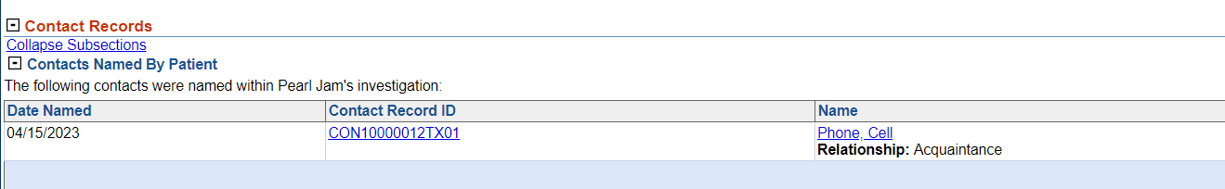

Part 2: Linking the contact’s investigation to the index/source case.
Link the specific investigation for Patient A. (Hint: Review Module 10, part 3, if you are not sure how to do this step).

- Provide a screenshot of the Patient Named By Contacts:
Review Screenshot, should show all this:
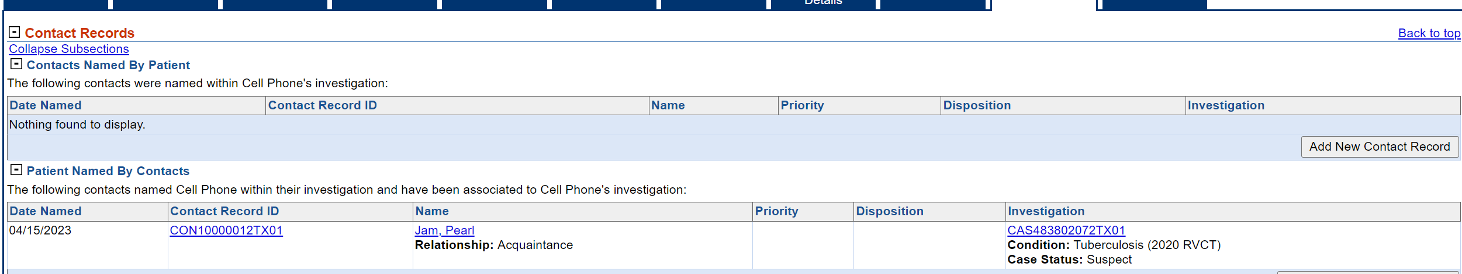

- What button in the Contact Record would you use as a shortcut to link the contact’s investigation?
Provider Decision: Link to Existing Investigation

