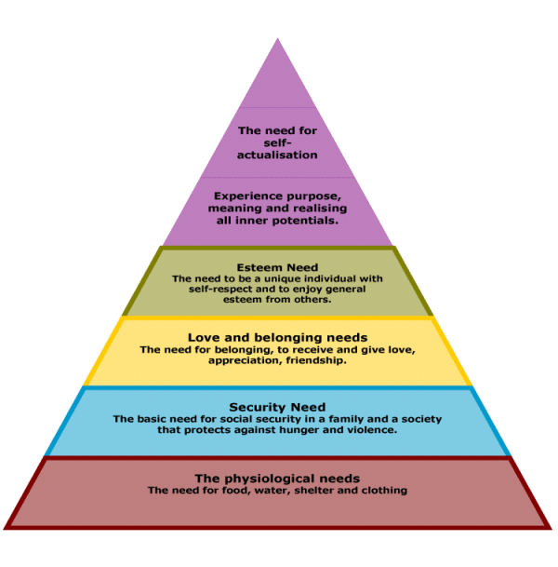
Maslow’s Hierarchy and Coordinated School Health
framework for helping the whole child be successful at school… and in life!
student
success!
classroom teachers counselors principals PE teachers parents nurses librarians social workers music teachers art teachers coaches custodians food service personnel assistant principals mentors curriculum staff secretaries administrators staff development providers SHAC receptionists school board business office workers classroom aides maintenance staff school resource officers athletic trainers school volunteers groundskeepers special education staff faith leaders community members wellness staff technology staff publications health educators psychologists human resources employees speech pathologists insurance staff
grandparents diagnosticians foster parents homebound teachers
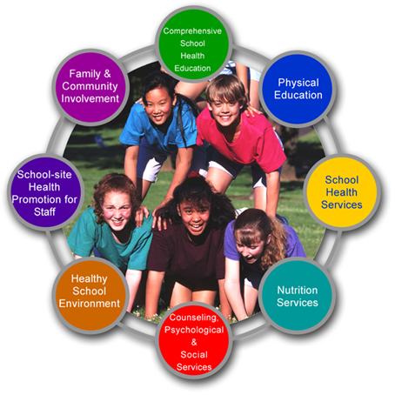
Together, we are the foundation for student success!

In Coordinated School Health, all
eight components function together
to provide a sound structure and team
approach for ensuring optimal health
in the school setting.
Healthy kids – better learners!
Coordinated School Health

