Prescription Drug Price Disclosure Program User Guide for Annual WAC Reporting Renewal
Step 1: Login under Returning User with the User ID and Password (use password provided by DSHS for first login, then change).
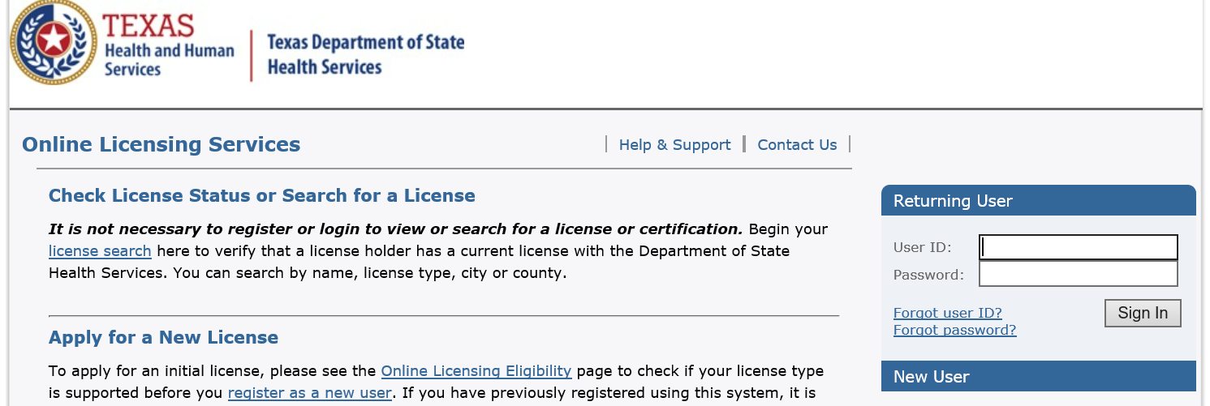

Step 2: Under ‘It is time to Renew’, click Select to the right of Annual Reporting.
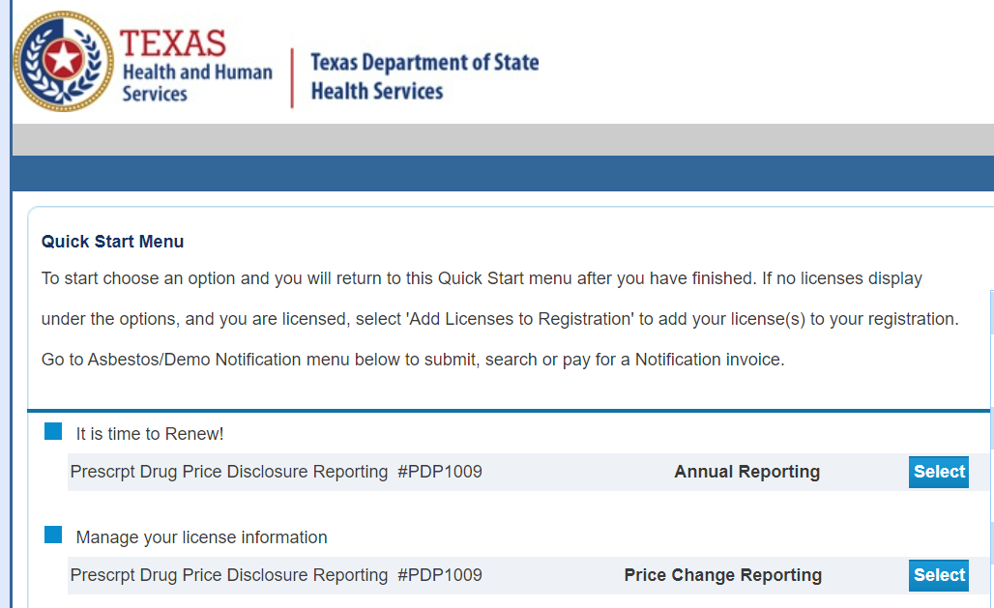

Step 3: Click Next to continue.
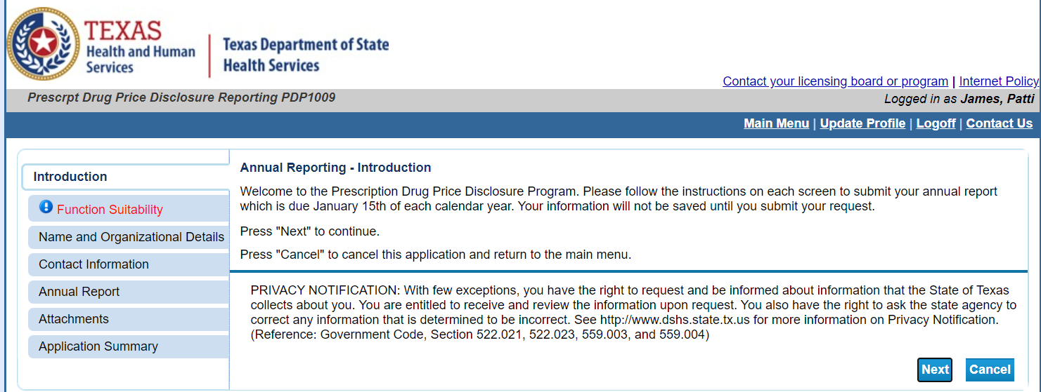

Step 4: Click No for both questions and click Next.
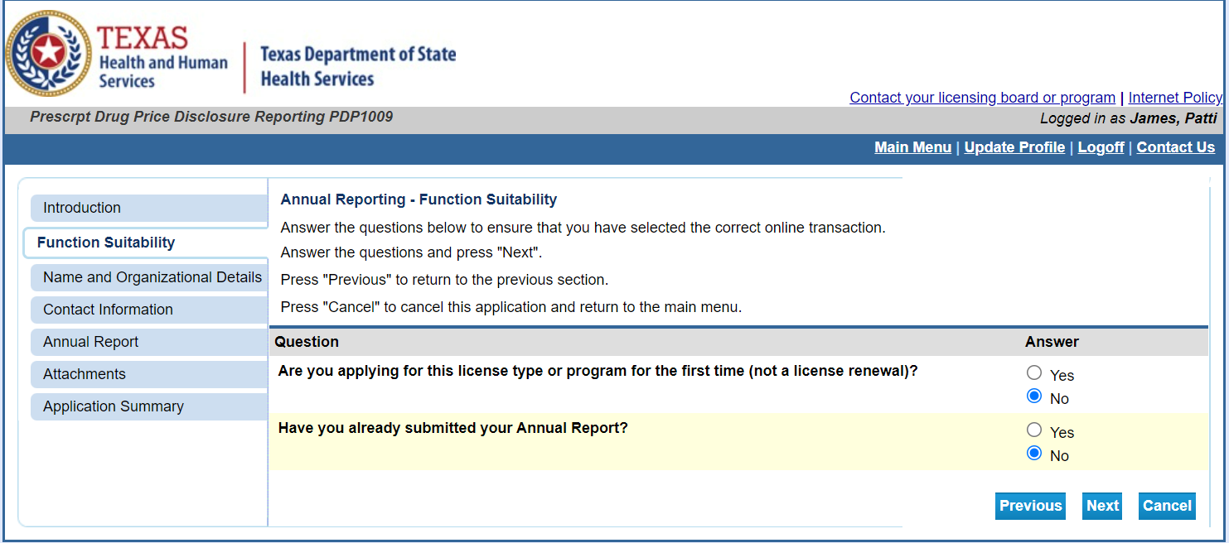

Step 5: Confirm Name and Organization and click Next.
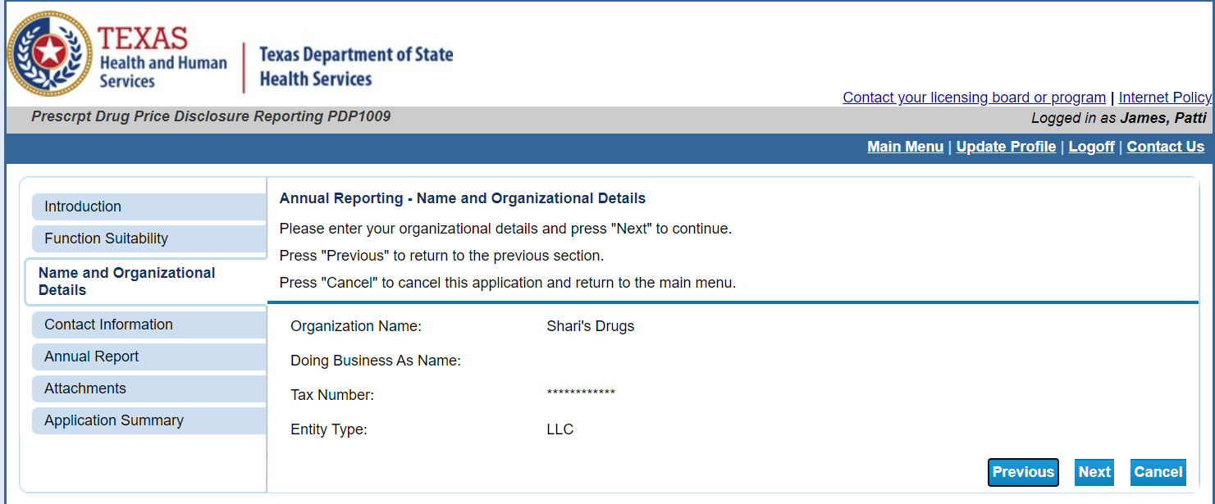

Step 6: Confirm/Enter contact information and click Next.
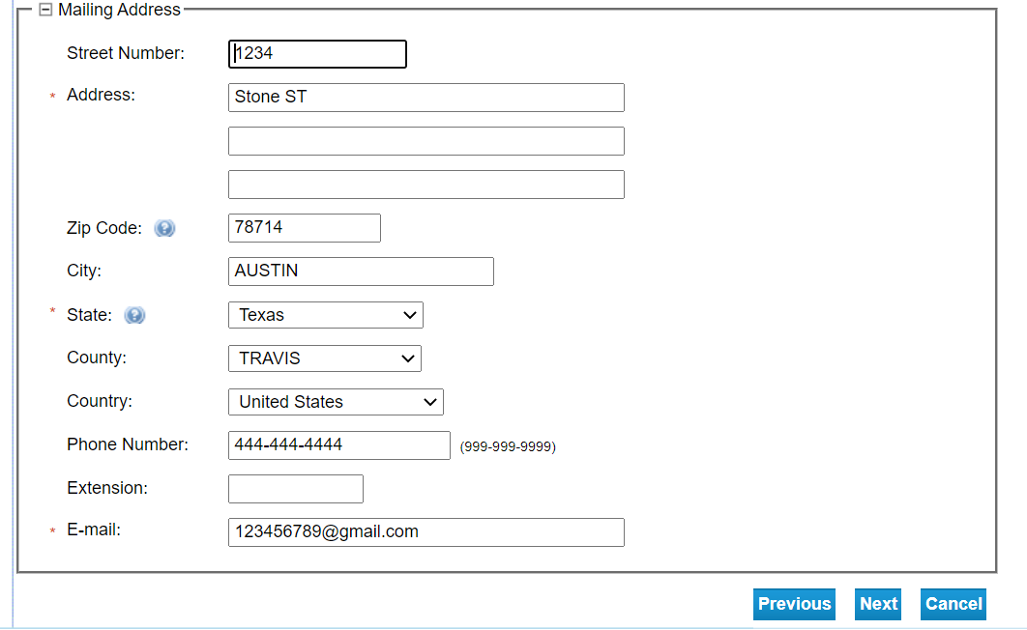

*Manufacturers can either individually enter their products on the annual report page (step 7 in the user guide) OR attach and upload the approved annual report template on the attachments page (step 8 in the user guide).*
**Please do not manually enter products AND attach the approved template with the same products-this will result in duplicate entries in the system.**

Step 7: Enter information for each drug reported. Click Add for more than one drug. Click Next when all drug reporting information has been entered.
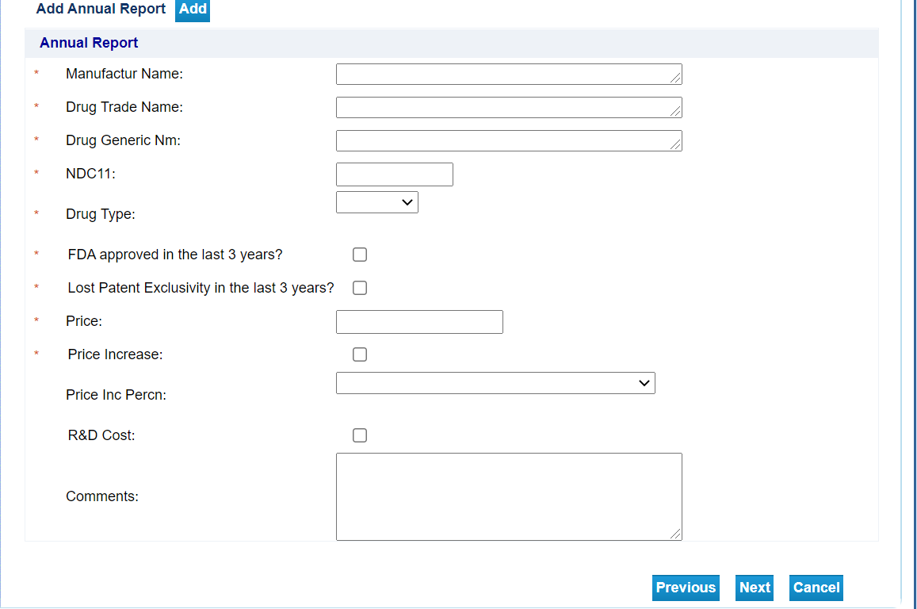

Step 8: Attach Annual Reporting Attachments. Manufacturers must use the approved Annual WAC Report Excel template for submitting Annual WAC Reports. Follow the link for the approved template. Users should not change formatting on the templates. Once done, click Next.
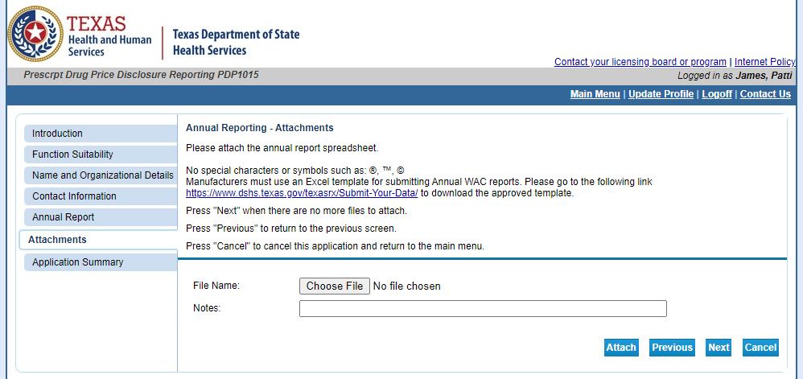

Step 9: Confirm Annual Report Summary and Submit.
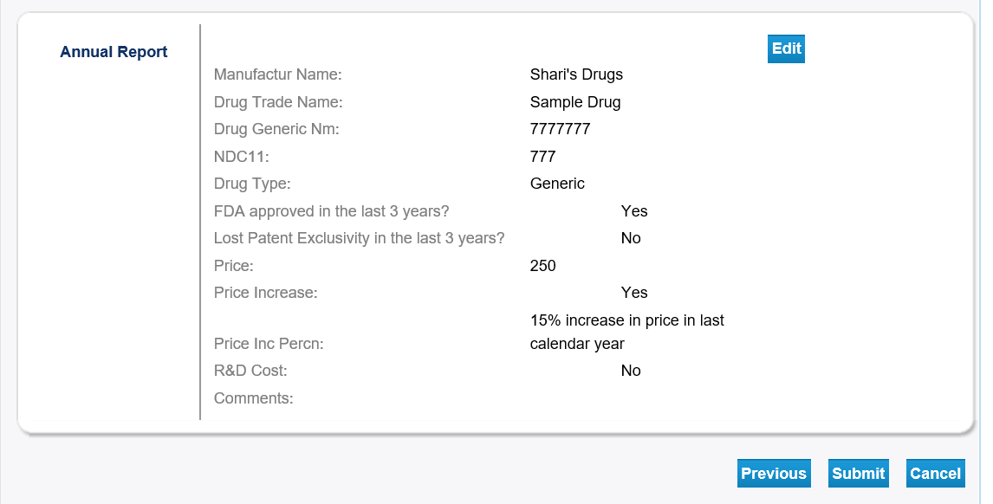

Step 10: Click Yes on Attestation and Submit.
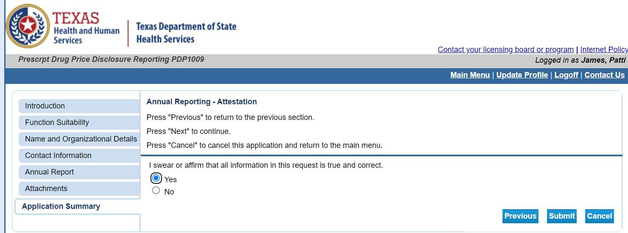

Step 11: Confirm application submission to finish.
