Prescription Drug Price Disclosure Program User Guide for Price Change Reporting
Step 1: Login under Returning User with the User ID and Password.
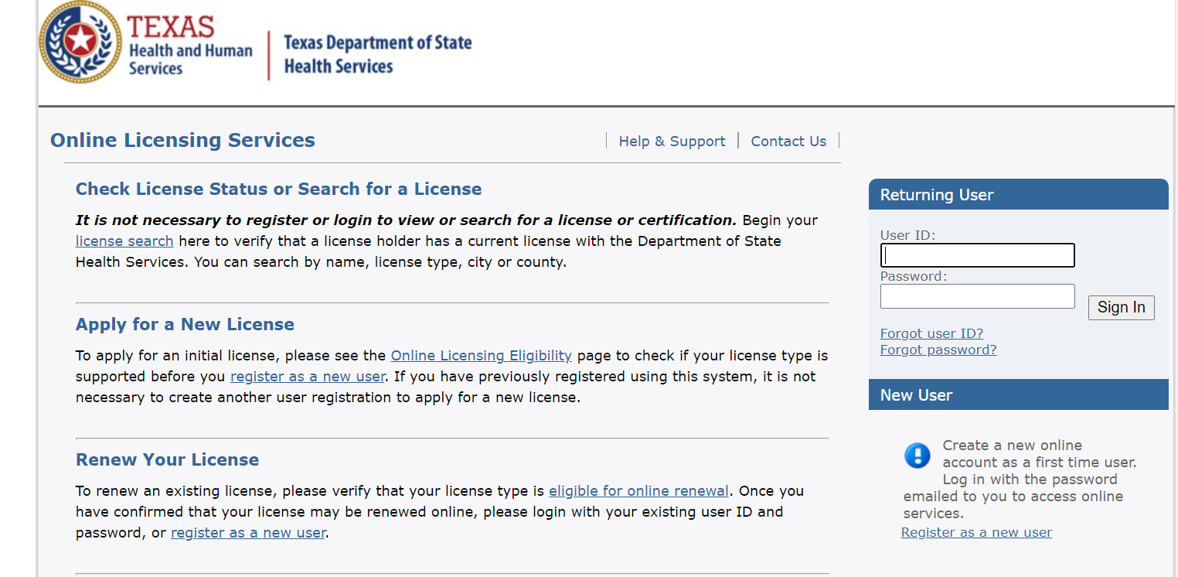

Step 2: Under ‘Manage your license information’, click Select to the right of Price Change Reporting.
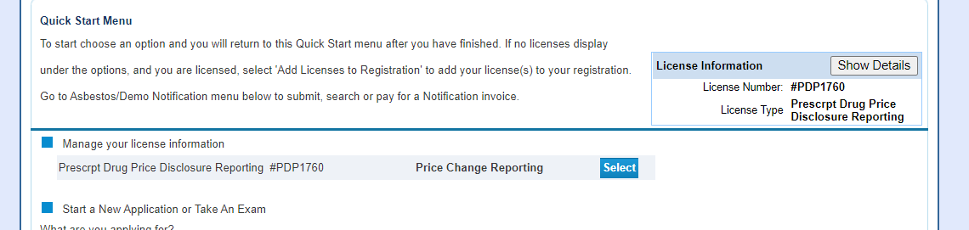

Step 3: Click Next to continue.
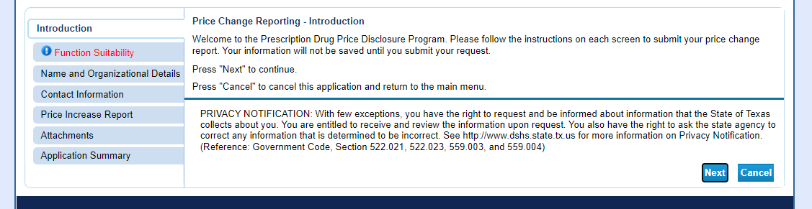

Step 4: Click No for ‘Are You Submitting Your Annual Report’ and then click Next.
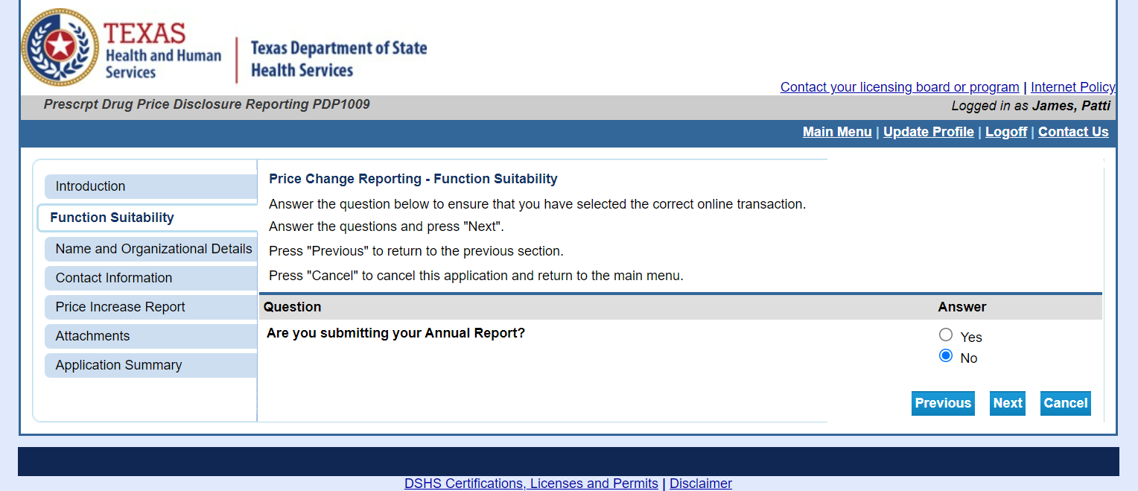

Step 5: Confirm Name and Organization and click Next.
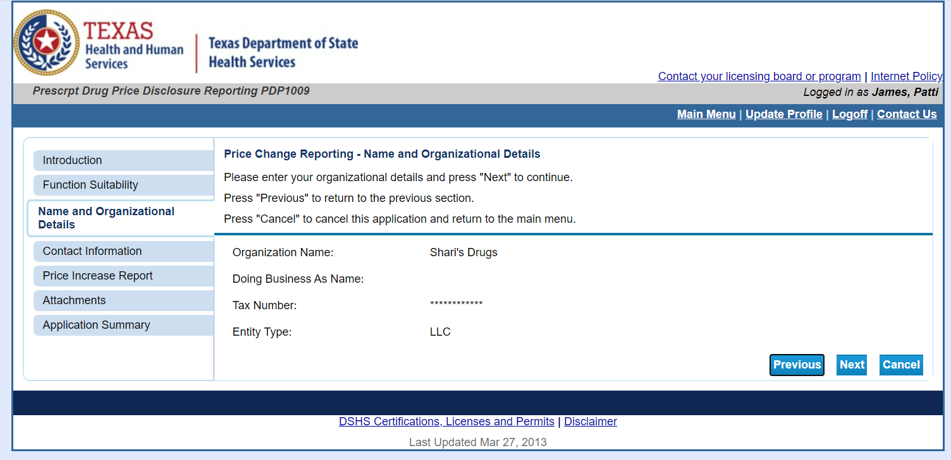

Step 6: Confirm/Enter contact information and click Next.
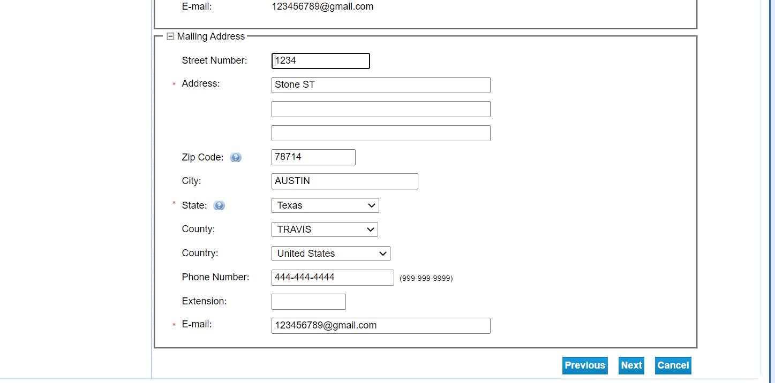

*Manufacturers can either individually enter their products on the price increase report page (step 7 in the user guide) OR attach and upload the approved price increase report template on the attachments page (step 8 in the user guide).*

**Please do not manually enter products AND attach the approved template with the same products-this will result in duplicate entries in the system.**

Step 7: Add Price Increase Report for each drug and click Next. Use the Add button for multiple drugs.
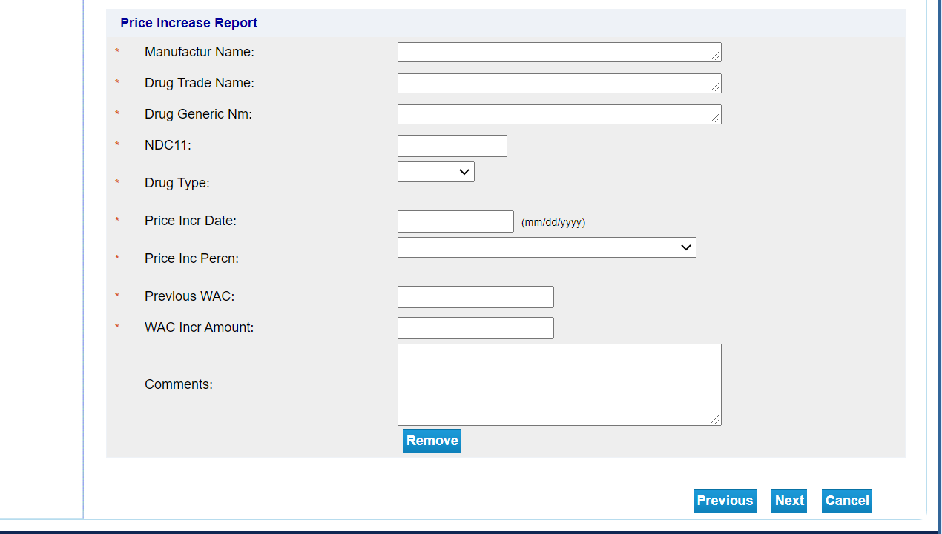

Step 8: Attach Price Change Reporting Attachments. Manufacturers must use the approved Price Increase Report Excel template for submitting Price Change reports. Follow the link for the approved template. Users should not change formatting on the templates. Once done, click Next.
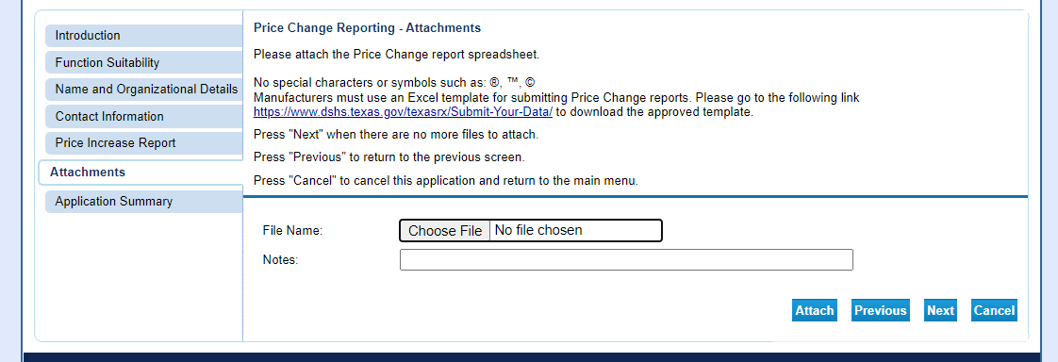

Step 9: Confirm Summary and Submit.
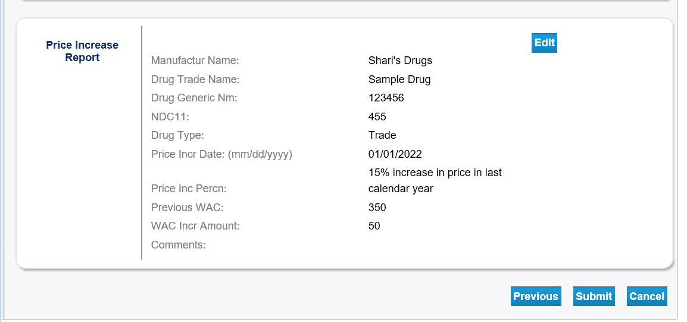
Step 10: Click Yes on Attestation and Submit.
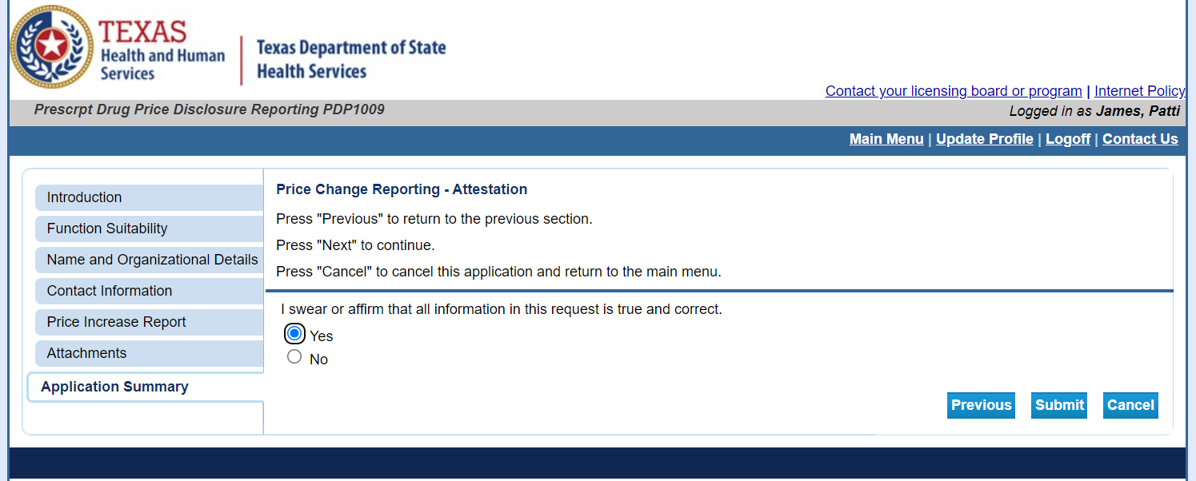

Step 11: Confirm application submission to finish.
