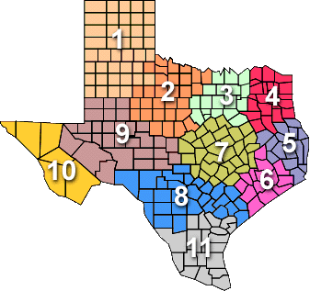 |  |   Measles VIRAL Specimen Collection
Specimen Type | PCR TESTING  ** Measles Specimens **
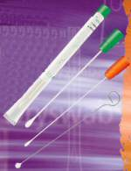  Materials | - Viral transport media (VTM) and tubes  - Specimen submission forms (G2V)  - Personal protective equipment  - Tongue depressors  - Polyester fiber tipped swabs - either Dacron or Rayon  - NO cotton tipped or wooden shaft swabs or any that contain calcium alginate
Proper Specimen Collection | - Do not use expired media – be sure to check the expiration date  - With mouth open, depress tongue  - Swab posterior pharynx, avoiding the tonsils  - Put tip of swab in the VTM, breaking applicator stick  - Seal properly  - Freeze or refrigerate  - Prepare for shipment  - Throat swabs are the preferred specimens for DSHS testing  - Nasopharyngeal swabs and urine are also acceptable specimens for measles testing
Specimen Handling | - Transport specimens to the laboratory as soon as possible  - Specimens should be placed in a biohazard bag and stored at 4°C or -70° C  - If specimens are shipped the same day of collection, ship at 4°C  - If specimens will be stored and shipped after the date of collection, freeze at -70° C  - DO NOT store samples in a standard freezer – this inactivates the virus  - DO NOT have repeated freeze thaw cycles – this inactivates the virus
Specimen Shipping | - Do not ship on Fridays or before government holidays  - Specimens stored at 4°C are shipped using cold packs  - Specimens stored at -70° C are shipped on dry ice  - Complete the G2V form for each specimen  - Check “Measles PCR” in Section 4 of the G2V  - The name on the tube should match the name on the form exactly  - Ship to the physical address ATTN: Lab Services  - Record the shipping tracking number and notify IDCU that a specimen is being shipped
Additional Information | - Collect as soon as possible after rash onset  - Preferably within five days  - Not more than ten days after onset  Centers for Disease Control and Prevention– Measles PCR  http://www.cdc.gov/measles/lab-tools/rt-pcr.html

 |  | Measles SERUM Specimen Collection
Specimen Type | IgM and IgG Antibody Testing  ** Measles Specimens **
Materials | - Red top tubes and serum separator tubes OR gold top OR tiger top tubes  - Specimen Submission forms (G2A)  - Personal Protective Equipment  - Centrifuge
Proper Specimen Collection | - Do not use expired tubes – be sure to check the expiration date  - RED TOP TUBE  - Collect at least 5mL of blood in red top tube  - Centrifuge the red top tube  - Transfer the serum into a serum transport tube  - GOLD/TIGER TOP TUBE  - Collect at least 5mL of blood in gold/tiger top tube  - Centrifuge the gold/tiger top tube  - Seal properly  - Refrigerate or freeze (do not freeze serum separator tubes, gold top tubes or whole blood)  - Prepare for shipment
Specimen Handling | - Transport specimens to the laboratory as soon as possible  - Specimens should be placed in a biohazard bag and stored at 4°C or -20° C  - If specimens are shipped the same day of collection, ship at 4°C  - If specimens will be stored and shipped after the date of collection, freeze at -20° C  - Do not freeze whole blood in red top tube for shipping  - Do not freeze serum in gold top or serum separator tube for shipping
Specimen Shipping | - Do not ship on Fridays or before government holidays  - Do not ship whole blood  - Specimens that will arrive at the lab within 48 hours of collection can be stored at 4°C and should be shipped using cold packs  - Specimens that will arrive at the lab more than 48 hours after collection should be stored at -20° C and shipped on dry ice  - Complete the G2A form for each specimen  - Check “Rubeola screen” and “Rubeola IgM” in Section 7 of the G2A  - The name on the tube should match the name on the form exactly  - Ship to the physical address ATTN: Lab Services  - Record the shipping tracking number and notify IDCU that a specimen is being shipped
Additional Information | - Collect as soon as possible after rash onset, up to 30 days  - Patients with an MMR vaccine in the past 6-45 days are not recommended for serology testing.  Centers for Disease Control and Prevention– Measles serology  http://www.cdc.gov/measles/lab-tools/serology.html

