Vision Assessments | Name:
Vision Assessments | DOB:

Ishihara Plates (Red/Green Color Discrimination): Indicated for patients taking ethambutol, linezolid. Instruct patient to keep both eyes open and document the number the patient sees on each plate. The (X) mark indicates the plate cannot be read. Screen all 14 plates. Patient must pass 10 of the first 11 plates for the test to be regarded as normal. Refer for evaluation if < 7 plates are read as normal. Results: [N] = Normal [A] = Abnormal
Ishihara Plate # | Normal Reading | Red/Green  Deficiency |  |  |  | Baseline | Date | Date | Date | Date | Date | Date | Date | Date | Date | Date | Date | Date
1 | 12 | 12
2 | 8 | 3
3 | 5 | 2
4 | 29 | 70
5 | 74 | 21
6 | 7 | X
7 | 45 | X
8 | 2 | X
9 | X | 2
10 | 16 | X
11 | Traceable | X
 |  | Protan |  | Deutan
 |  | Strong | Mild | Strong | Mild
12 | 35 | 5 | (3) 5 | 3 | 3 (5)
13 | 96 | 6 | (9) 6 | 9 | 9 (6)
14 | Can trace  2 lines | Purple | Purple (Red) | Red | Red (Purple)
 |  |  |  |  | Results
 |  |  |  |  | Initials

Visual Acuity: Indicated for patients on ethambutol, linezolid. If initial screen was conducted with corrective lenses (glasses or contacts), follow-up screens must be done the same. Test each eye separately and then both eyes open together. A change of one or more lines from initial screen in one or both eyes must be reported to the physician immediately. Chart Used: Letter “E” Other:
Corrective Lenses: Yes No
Distance Acuity | Baseline | Date | Date | Date | Date | Date | Date | Date | Date | Date | Date | Date | Date
Right Eye | 20/ | 20/ | 20/ | 20/ | 20/ | 20/ | 20/ | 20/ | 20/ | 20/ | 20/ | 20/ | 20/
Left Eye | 20/ | 20/ | 20/ | 20/ | 20/ | 20/ | 20/ | 20/ | 20/ | 20/ | 20/ | 20/ | 20/
Both Eyes | 20/ | 20/ | 20/ | 20/ | 20/ | 20/ | 20/ | 20/ | 20/ | 20/ | 20/ | 20/ | 20/

Initials

Heart Rhythm Monitoring Assessment
Heart Rhythm Monitoring Assessment | Name:
 | DOB:
Cardiac Monitoring: Indicated for patients taking bedaquiline. Perform electrocardiogram (ECG) at minimum: baseline, at two weeks, and monthly. ECGs must be placed by staff trained in placement, performed at the same time of day each time, and read by the treating physician or designee within (1) working day. Mark initials of person who performed ECG and [check mark] when reviewed by physician. If ECG performed outside the health department, mark “other” on “Performed by” and include in progress note. Type used: ☐ 12-lead ECG ☐ Other:
ECG | Baseline | Date | Date | Date | Date | Date | Date | Date | Date | Date | Date | Date | Date
Time
Performed by
QTc Interval
Heart Rate
Reviewed by MD

Cardiac Assessment: Documentation of cardiac symptoms should be included when performing the ECG for patients on bedaquiline or as indicated by the treating physician. Results of both the signs and symptoms assessment and ECG should be provided to the treating physician for review. Expand on any symptoms in a progress note detailing onset, duration, type, quality, etc.
Signs and Symptoms | Baseline | Date | Date | Date | Date | Date | Date | Date | Date | Date | Date | Date | Date
Chest pain | Yes  No | Yes  No | Yes  No | Yes  No | Yes  No | Yes  No | Yes  No | Yes  No | Yes  No | Yes  No | Yes  No | Yes  No | Yes  No
Palpitations | Yes  No | Yes  No | Yes  No | Yes  No | Yes  No | Yes  No | Yes  No | Yes  No | Yes  No | Yes  No | Yes  No | Yes  No | Yes  No
Shortness of breath | Yes  No | Yes  No | Yes  No | Yes  No | Yes  No | Yes  No | Yes  No | Yes  No | Yes  No | Yes  No | Yes  No | Yes  No | Yes  No
Feeling increased heart rate | Yes  No | Yes  No | Yes  No | Yes  No | Yes  No | Yes  No | Yes  No | Yes  No | Yes  No | Yes  No | Yes  No | Yes  No | Yes  No
Fainting/Syncope | Yes  No | Yes  No | Yes  No | Yes  No | Yes  No | Yes  No | Yes  No | Yes  No | Yes  No | Yes  No | Yes  No | Yes  No | Yes  No
Light-headedness | Yes  No | Yes  No | Yes  No | Yes  No | Yes  No | Yes  No | Yes  No | Yes  No | Yes  No | Yes  No | Yes  No | Yes  No | Yes  No
Loss of consciousness | Yes  No | Yes  No | Yes  No | Yes  No | Yes  No | Yes  No | Yes  No | Yes  No | Yes  No | Yes  No | Yes  No | Yes  No | Yes  No
Nurse initials

Mental Health Assessment | Name:
Mental Health Assessment | DOB:
Mental Health Status: Assess depression, psychosis and overall mental health status for patients on cycloserine, clofazimine. Tools are available from Heartland National TB Center: heartlandntbc.org/assets/products/mental_health_screening_tool.pdf, Curry International TB Center: currytbcenter.ucsf.edu/products/nursing-guide-managing-side-effects-drug-resistant-tb-treatment or other professional screening tools preferred by the treating physician. Tool Used: Heartland National TB Center Mental Health Screening Curry Nursing Guide Other:
Results: Document numeric score and/or [N] = Normal [A] = Abnormal
 | Baseline | Date | Date | Date | Date | Date | Date | Date | Date | Date | Date | Date | Date
Tool | Results
Date | Notes/interventions based on score or result of assessment | Initials
Baseline:

Tendon Assessment | Baseline | Date | Date | Date | Date | Date | Date | Date | Date | Date | Date | Date
All tendons palpated
Pain or tenderness
Redness/warmth to touch

Swelling

Site of concern

Initials
Tendon Assessment
Tendon Assessment: Indicated for patient on a fluoroquinolone (FQN) - either levofloxacin (LFX) or moxifloxacin (MFX). Tendons most affected are those located in the shoulder, hands, and base of ankle (Achilles tendon). However, any tendon may be involved, and nurses should palpate tendons to identify abnormalities. See Tendon Assessment resource. Results: [ Y ] = Yes [ N ] = No

Peripheral Neuropathy Assessment | Name:
Peripheral Neuropathy Assessment | DOB:
Peripheral Neuropathy Monitoring: Complete a baseline and monthly assessment of the hands and feet while patient is on high doses of isoniazid (adults ≥15mg/kg), linezolid. First ask patient the assessment questions. Next, test sensations using a 4.31/2gm monofilament for the hands and a 5.07/10g monofilament for the foot. Refer to “Peripheral Neuropathy Assessment Process” for detailed instructions:dshs.texas.gov/disease/tb/forms). Notify the treating physician if abnormality or change (i.e. diminished or no sensation) is identified. Assessment adapted from Heartland National Tuberculosis Center.
Bilateral Upper Extremities (BUE)-hands, arms  1. Do you have any pain or numbness in BUE?  Y N If yes, describe: |  | Bilateral Lower Extremities (BLE)- feet, legs  1. Do you have any pain or numbness in your BLU?  Y N If yes, describe:
2. If YES to #1, is the pain made worse with the touch of clothing or bed sheets? Y N  3. Do you have any of the following characteristics in the BUE? Burning Freezing  Electric shock-type sensation Tingling  Pricking Numbness Stinging/itching  Other, describe:  None  4. In general, do you have the following in the BUE:  Hypoesthesia to touch? Y N L R  Hypoesthesia to prick? Y N L R  Extreme sensitivity to touch? Y N L R  Extreme sensitivity to prick? Y N L R |  | 2. If YES to #1, is the pain made worse with the touch of clothing or bed sheets? Y N  3. Do you have any of the following characteristics in BLE? Burning Freezing  Electric shock-type sensation Tingling  Pricking Numbness Stinging/itching  Other, describe:  None  4. In general, do you have the following in BLE:  Hypoesthesia to touch? Y N L R  Hypoesthesia to prick? Y N L R  Extreme sensitivity to touch? Y N L R  Extreme sensitivity to prick? Y N L R
Perform physical assessment using monofilaments on the area specified by the circle (O). Document [+] if NORMAL and [–] if ABNORMAL/DIMINISHED/ABSENT sensation noted.
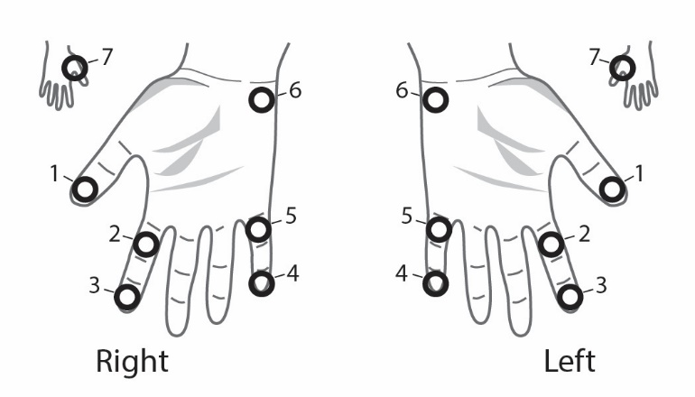 |  | 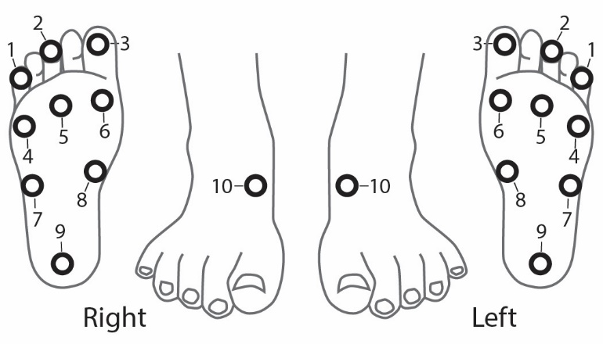
1 2 3 4 5 6 7 | 1 2 3 4 5 6 7 | 1 2 3 4 5  6 7 8 9 10 | 1 2 3 4 5  6 7 8 9 10
Notes:
Performed by (Name/Initials): Date:

Monthly Toxicity Assessment | Name:
Monthly Toxicity Assessment | DOB:
Ask all questions baseline, monthly to identify potential medication* toxicity. Document details in progress note any [+] responses including potential pregnancy & notify physician. Results: [+]=Present; [-]=Denies; [NA]=Not Applicable
 | Base. | Date | Date | Date | Date | Date | Date | Date | Date | Date
Weight
BMI
Temperature
Blood Pressure
Pulse
Do you have any of the following symptoms now or since your last clinic appointment?
Abdominal pain/diarrhea
Anxiety/Abnormal behavior (nightmares, hallucinations, aggression, disorientation) (CS)
Allergic reaction (specify)
Arthralgia/tendon pain, redness or swelling (FQN)
Bruises, red/purple spots on skin
Change in heart rate (BDQ, FQN)
Change in urine output
Convulsions (CS, FQN)
Dark urine-coffee colored/color change
Ears ringing/hearing loss (AK)
Eye pain/irritation (red; excessive tears)
Fever or chills
Flu-like symptoms
Headaches
Increased gas/stomach cramps
Jaundice (yellow skin/eyes)
Joint pain/swelling (PZA)
Light colored stools
Loss of appetite
Malaise/fatigue
Memory Loss
Mood changes/depression (CS, CFZ)
Musculoskeletal Pain
Nausea/vomiting
Numbness/tingling/pain, arms, legs
Nervous/Giddiness/Restlessness
Photosensitivity (sunburn, rash, blisters) (FQN)
Skin discoloration
Skin rashes/itching
Sleep problems
Sores on lips or inside mouth
Shortness of breath
Teeter/Fall when standing (eyes closed)
Unusual bleeding (nose, gums, stool, urine, etc.) or easy bruising (RIF, RPT)
Vertigo/dizziness/fainting
Visual problems/changes- (EMB, RBT, LZD)
Weakness, tiredness
Weave/Stagger when walking
Over the counter meds (i.e. Tylenol)?
Ask women about pregnancy/LMP
Nurse Initials
Interpreter Initials
*Refer to the Nursing Guide for Second-Line Tuberculosis Medications for acronyms used.

