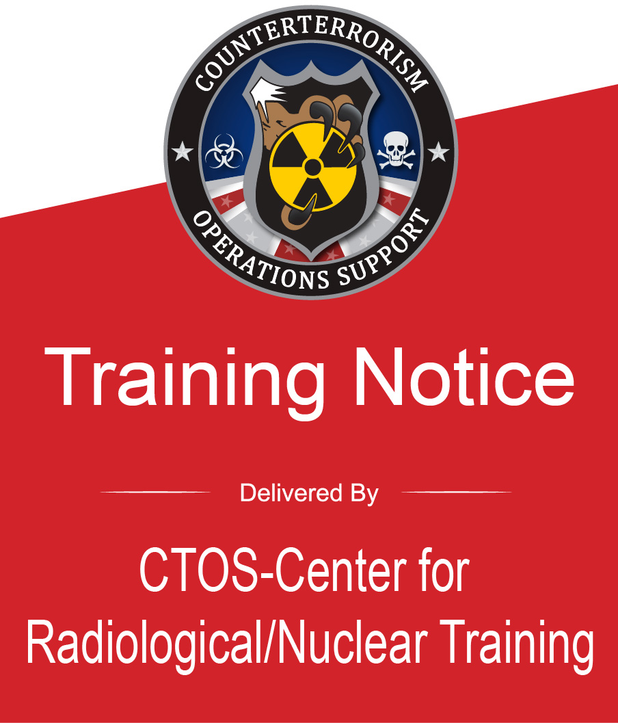 | Preventive Radiological/Nuclear Detection Team Operations Course (PER-318)  Hosted By: Grand Prairie Fire Department  Location: Grand Prairie EOC  1790 Robinson Road  Grand Prairie, TX 75051  Hours: 0800 - 1700 (each day)  Dates: April 27 - 29, 2026  Course Length: 28 contact hours (4 Days)  Prerequisites: AWR-140, PER-243, PER-246, PER-245
Course Description:
This four-day course provides Primary and Secondary Screeners the skill sets needed to maximize their PRND equipment capabilities to efficiently and effectively perform the essential tasks to protect and secure critical infrastructure, large venues, and special events using National Incident Management System (NIMS) typed teams. The exercises are based on specific competencies, behaviors, and tasks utilizing typed personnel, equipment, and teams.
REGISTER TODAY!
If you Do Not have an account:  - Navigate to the Acadis Homepage https://ctos.acadisonline.com/  - Select the WebForms link.  - Select New User Account Request. Complete all fields including Applicant Certification.  Note: To receive credit for this FEMA course, a valid Student Identification (SID) Number is required on the Account Request. A SID number can be obtained at the following link: https://cdp.dhs.gov/femasid  - Select Submit on the bottom of the page.  - You will receive an email within 48 hours with your new LMS account information and a request to set up a password.  If you already have an account:  - Navigate to the Acadis Homepage and sign in.  - From the Home Page, click on the Training and Events-Browse or Sign up for Training tab. Select your class and follow the LMS prompts.  If you are experiencing issues logging into your account use the Account Help link on the Acadis Homepage. |  | 