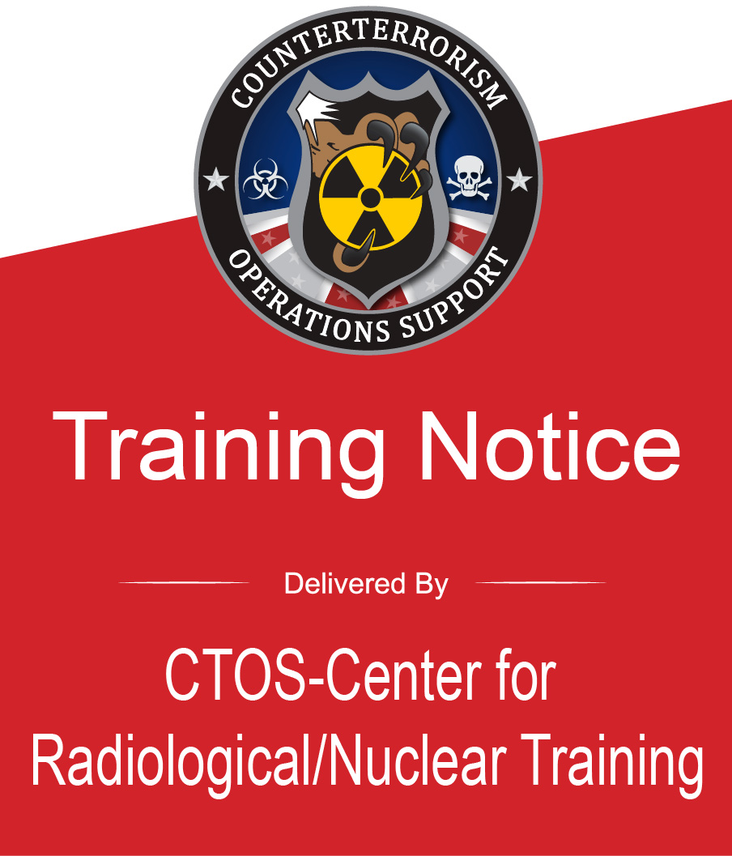 | PER-351 - Preventive Radiological/Nuclear Detection Team Leader  Hosted By: Grand Prairie Fire Department  Location: Grand Prairie EOC  1790 Robinson Road  Grand Prairie, TX 75051  Hours: 0800 - 1700 (each day)  Dates: May 18 - 19, 2026  Course Length: 14 contact hours (2 Days)
Course Description:
PER-351 uses real-world scenarios to train Participants how to plan PRND operations using the Incident Command System (ICS) and NIMS typed resources. The Incident Action Plan (IAP) format—with applicable ICS forms—will be used. Missions will include choke points, checkpoints, and area and facility sweeps. The scenarios will range in size from single resource assignments through a Special Event Assessment Rating (SEAR) 1 or 2 event with nationally deployed assets. Participants will be able to demonstrate the supervisory skills required of the Team Leader position and demonstrate proficiency in the performance of the duties associated with the position, as outlined in the NIMS typing documents.
REGISTER TODAY!
If you Do Not have an account:  - Navigate to the Acadis Homepage https://ctos.acadisonline.com/  - Select the WebForms link.  - Select New User Account Request. Complete all fields including Applicant Certification.  Note: To receive credit for this FEMA course, a valid Student Identification (SID) Number is required on the Account Request. A SID number can be obtained at the following link: https://cdp.dhs.gov/femasid  - Select Submit on the bottom of the page.  - You will receive an email within 48 hours with your new LMS account information and a request to set up a password.  If you already have an account:  - Navigate to the Acadis Homepage and sign in.  - From the Home Page, click on the Training and Events-Browse or Sign up for Training tab. Select your class and follow the LMS prompts.  If you are experiencing issues logging into your account use the Account Help link on the Acadis Homepage. |  | 