Name: #:  BD: / / Age: yrs m |  |  | Dysmorphology Exam |  |  |  |  |  |  | Examiner: Date / /  Setting:
 | Ht: ( %; 50th for age ) HR RR BP /  Wt: ( %: 50th for age ) OFC ( %; 50th for age )  ◻ Underweight for height ◻ Short stature ◻ Microcephaly  ◻ Overweight for height ◻ Tall stature ◻ Macrocephaly |  |  |  |  |  |  |  |  | SCORING  ☑ Normal or:  ☑ Anomaly present: comments  ☑-- other finding
 | ◻ Normal ◻ Unusual texture:  ◻ Sparse/alopecia  ◻ Unusual pattern, extra whorls  ◻ Unruly, uncombable |  |  |  |  | 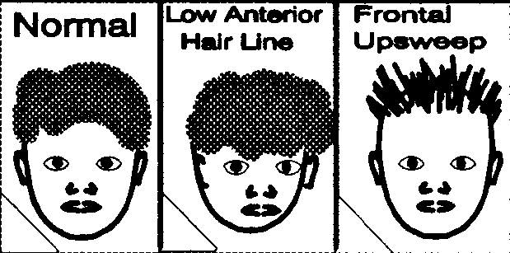 |  |  |  |  | 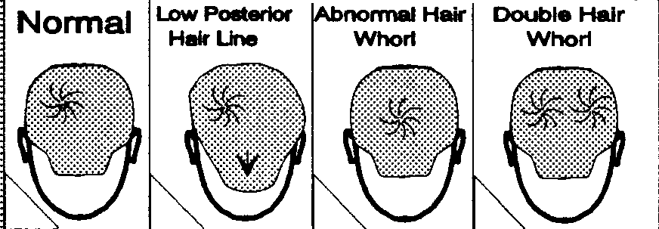
 | ◻ Normal ◻ Abnormal shape:  ◻ Ridged suture(s):  ◻ Open suture(s):  ◻ Abnormal fontanelle(s): ( cm x cm)  ◻-- ◻-- |  |  |  |  |  |  | 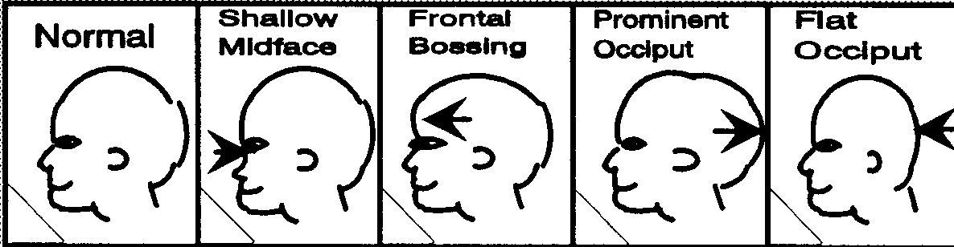
 | ◻ Normal ◻ Unusual gestalt::  ◻ Asymmetry:  ◻ Round ◻ Coarse ◻ Long/ narrow ◻ Myopathic  ◻-- ◻-- |  |  |  |  |  | 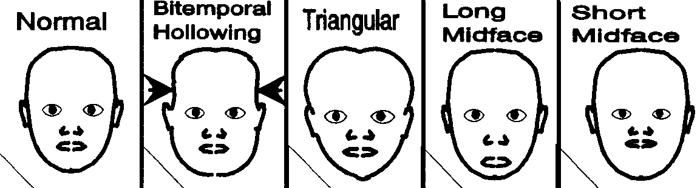
 | ◻ Normal  Eyebrows: ◻ Arched ◻ Medial flare  Eyelids: ◻ Ptosis ◻ --  Eye fissures ◻ Narrow ◻ Wide  Eye slant ◻↑ ◻ ↓ ◻ --  Sclerae ◻ Blue ◻ --  ◻ Iris: ◻ Pupils: |  |  | 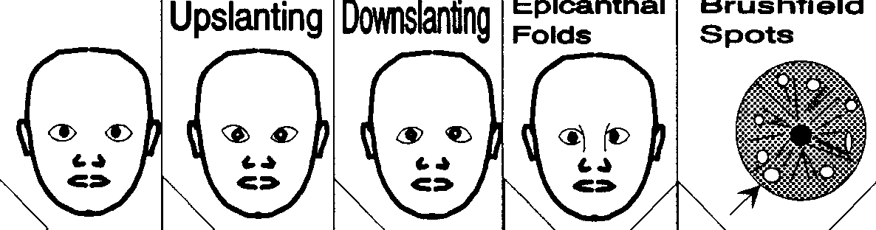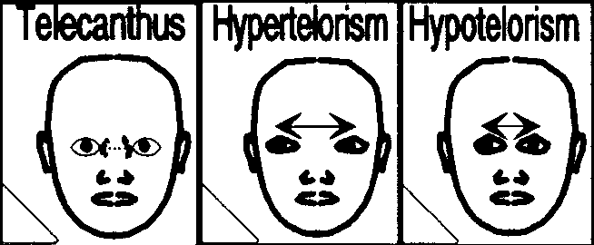
◻-- Intercanthal distance Interpupillary distance
◻-- cm ( ____%)* cm ( ____%) *
 | ◻ Normal  Simplified ◻R: ◻L:  Pits/grooves ◻R: ◻L:  Tags ◻R: ◻L: |  |  | ◻ R ear cm ( ___%)* ◻Large ◻Small  ◻ L ear cm ( ___%)* ◻Large ◻Small  Pinnae ◻R: ◻L:  Lobes ◻R: ◻L:  ◻R-- ◻L-- |  |  |  |  |  |  |  |  |  | 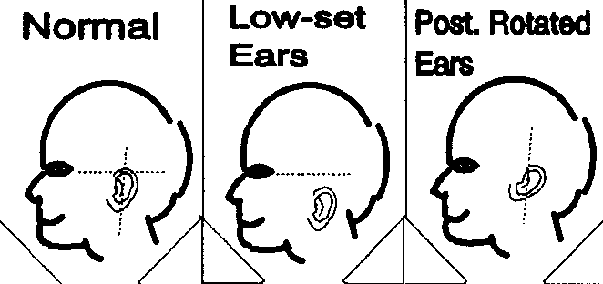
 | ◻ Normal ◻ Absent/cleft ◻ Proboscis ◻--  ◻ Long ◻ Short ◻ Shallow bridge ◻ High bridge  ◻ Short columella ◻ Alae above tip ◻ Deep nasal creases  ◻ Nasal tip: ◻ Nares: ◻-- |  |  |  |  |  |  |  | 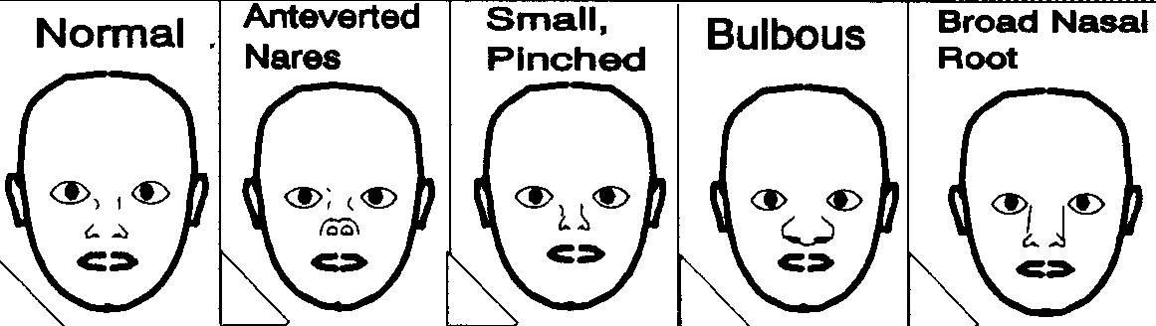 |  |  |  |  |  | sal
 | ◻ Normal ◻Cupid’s bow ◻↓ Corners  ◻ Open ◻ Locked ◻ Smile:  ◻-- ◻--  Tongue: ◻Large ◻Small ◻:  Teeth ◻ Too few ◻Small ◻ Conical/peg  ◻ Spacing: ◻--  Lips: ◻ Thin: ◻ Thick: |  |  |  | 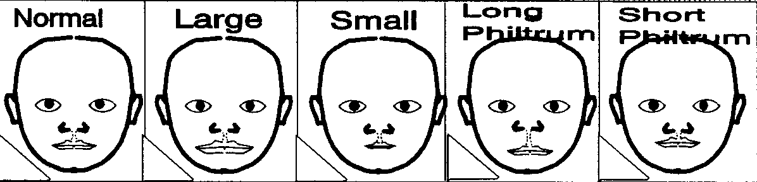  ◻ Mouth: |  |  |  |  |  |  | 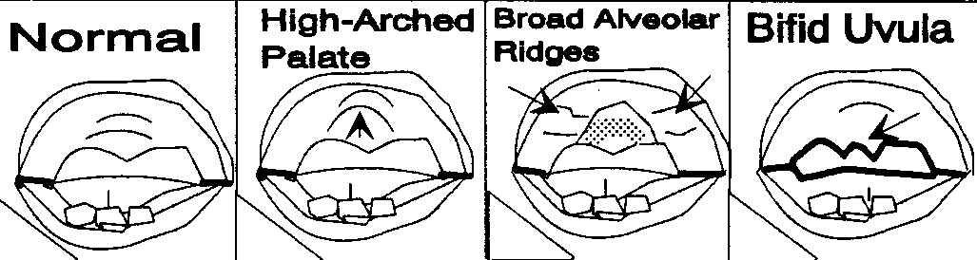  ◻ Palate:
 | ◻ Normal neck  ◻ Redundant skin  ◻ Torticollis:  ◻ Pits/sinuses:  ◻ Masses:  ◻-- | 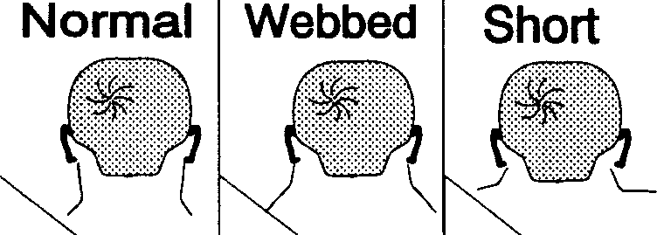 |  |  |  | ◻ Normal jaw  ◻ Retrognathia  ◻ Pointed chin  ◻ Cleft chin:  ◻-- |  |  |  |  |  |  | 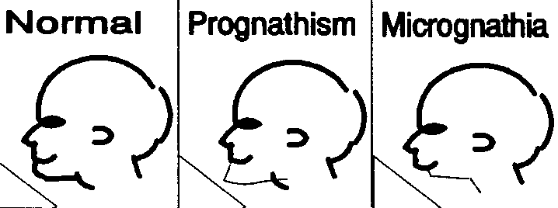
*score as abnormal if divergent from head circumference centiles

Dysmorphology exam (continued) Name: BD / / #
 | ◻ Normal chest ◻Small ◻Broad ◻--  Nipples ◻ Hypoplastic ◻ Widely spaced ◻--  Sternum ◻ Cleft/absent xiphoid ◻ Short sternum ◻--  Pectus ◻ Carinatum ◻ Excavatum ◻-- |  |  |  |  |  |  |  | ◻ Normal heart ◻--  ◻ Murmur :  ◻ Click: ◻ Rhythm:  ◻ Pulses:
 | ◻ Normal abdomen  ◻ Extra skin/prune belly  ◻ Umbilicus:  ◻ Hepatomegaly: FB below LCM  ◻ Splenomegaly:  ◻-- |  | 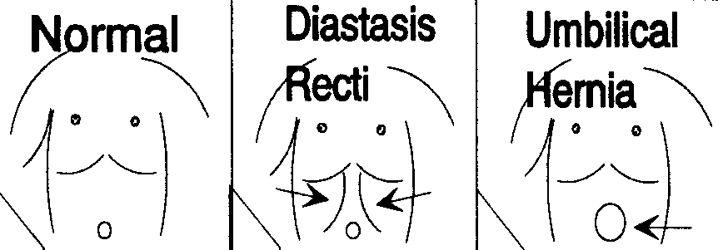 |  |  |  |  |  | ◻ Normal back  ◻ Scoliosis  ◻ Kyphosis/gibbus  ◻ Hirsutism  ◻ Sacral dimple/sinus  ◻--
 | ◻ Normal male genitalia Penis length cm  Penis ◻ Large ◻ Small ◻--  ◻ Chordee ◻ Hypospadias ◻ Epispadias  Scrotum ◻ Small ◻--  Testes ◻Large ◻Small ◻-- |  |  | 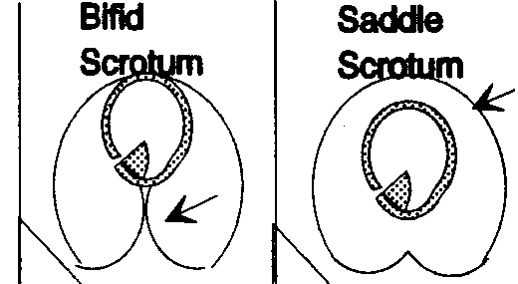 |  |  |  |  | ◻ Normal female genitalia  ◻ Virilized:  ◻ Hypoplastic labia/large clitoris  ◻ Vagina: ◻ Labia:  ◻--
 | ◻ Normal limbs ◻ Asymmetry: ◻--  Upper limbs ◻ Short (◻Proximal-rhizo ◻Middle-meso) ◻ Long  Lower limbs ◻ Short (◻Proximal-rhizo ◻Middle-meso) ◻ Long  ◻ Asymmetry:  Measures: R: L: |  |  |  |  |  |  | ◻ Normal joints ◻--  ◻ Lax:  ◻ Tight:  ◻ Contractures:  ◻ Webs: ◻ Dimples:
 | ◻ Normal hands ◻ Large ◻ Small ◻ Broad  Thumbs ◻ Broad ◻ Low placed ◻--  Fingers ◻ Broad ◻ Splayed ◻ Extra:  ◻ Fused: ◻ Short metacarpals 4/5  Nails ◻ Small/absent ◻ Brittle ◻-- |  |  |  | 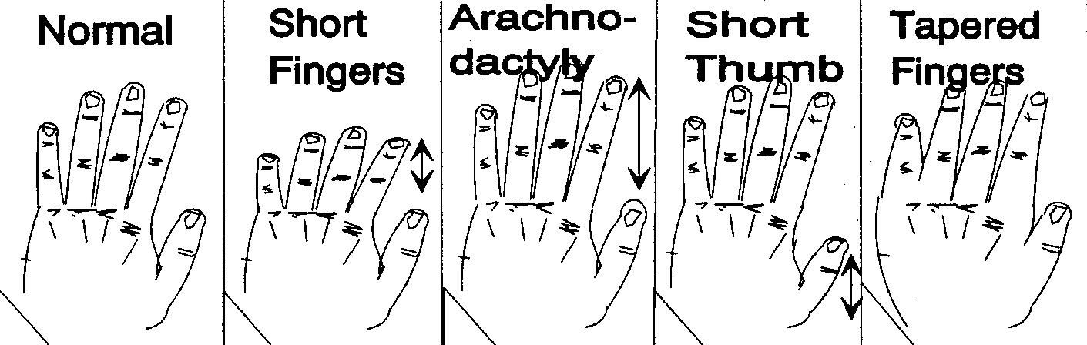 |  |  |  |  |  | 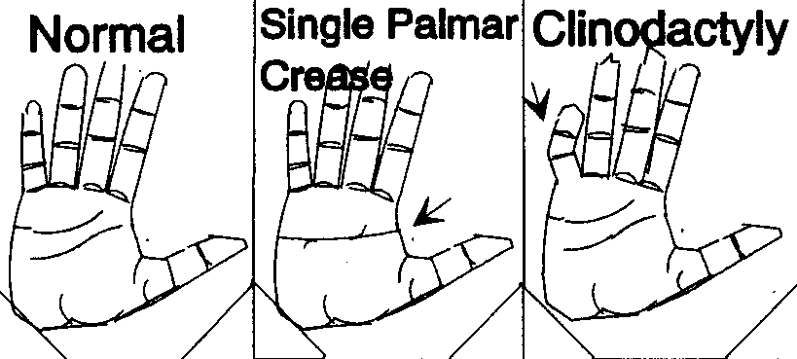
 | ◻ Normal feet ◻ Large ◻ Small ◻ Broad  Great toes ◻ Broad ◻ Deviated ◻--  Toes ◻ Broad ◻ Splayed ◻ Overlapping:  ◻ Fused: ◻--  Nails ◻ Small/absent ◻ Brittle ◻-- |  |  |  |  | 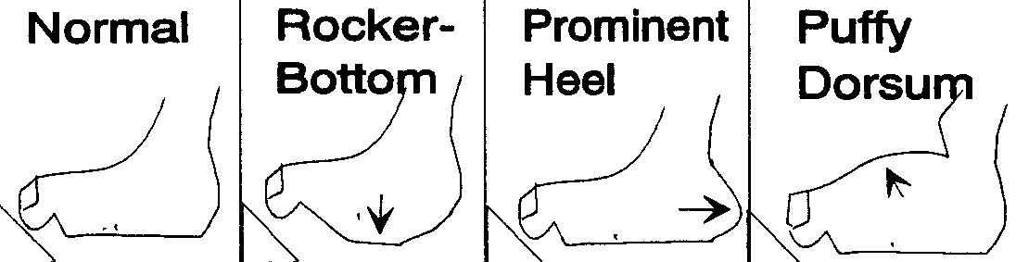 |  |  |  |  |  | 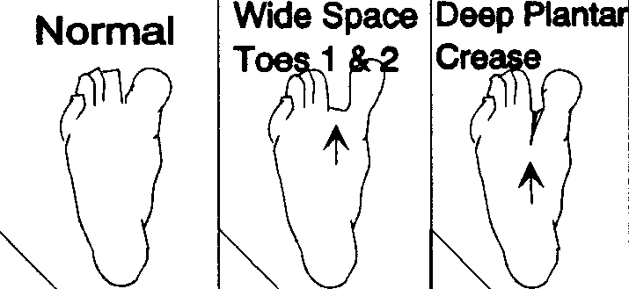
 | ◻ Normal ◻ Aged/thin  ◻Hyperelastic ◻ Lax  ◻ Scaly ◻ Thick  ◻ Unusual scars: →  ◻ Growths/lumps: →  ◻ Pigmented spots: →  ◻ Depigmented spots: →  ◻ Moles/nevi: →  ◻ Hemangiomas: →  ◻-- → | Diagram distribution ablesions |  |  |  |  |  |  |  | 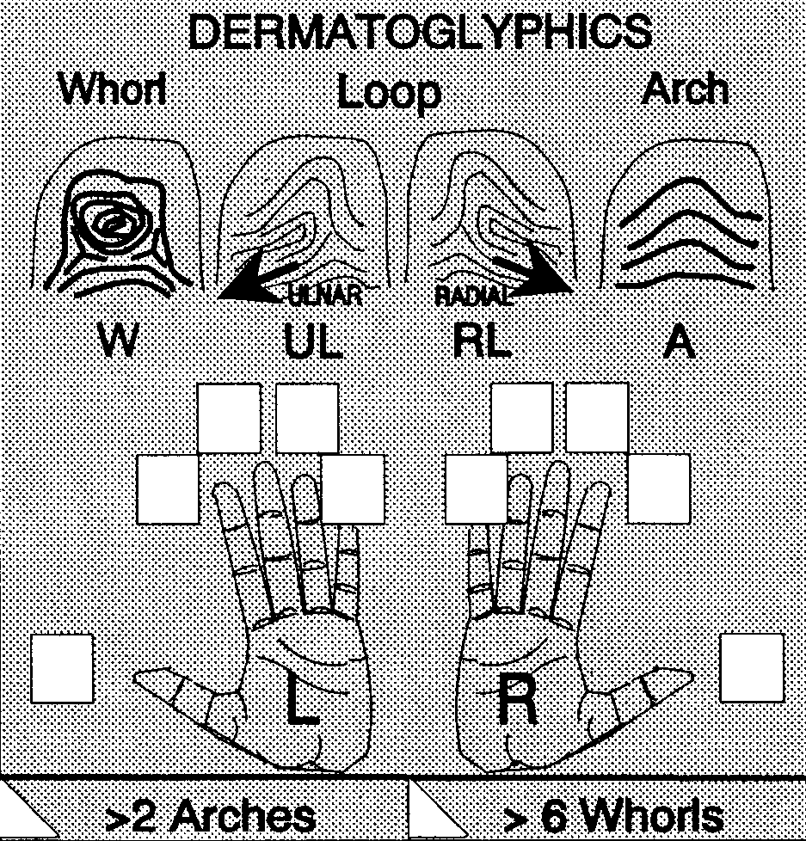
 | ◻ Normal ◻ Cranial nerve defect:  ◻ Abnormal reflexes:  DTRs ◻ UE__+ ◻ LE__ + ◻--  ◻ Ataxia: ◻ Poor tandem walk  ◻-- |  |  |  |  |  | Movements ◻ Asymmetry: ◻ Mirror  ◻ Repetitive: ◻--  Muscles: ◻↓ Strength: ◻ ↓ Mass:  Tone ◻ Hypo: ◻ Hyper:  ◻ Speech:
 | ◻ Normal Activity ◻ Distractable/poor focus ◻ Hyper  ◻ Autistic:  ◻-- |  |  |  |  |  | ◻ Self-mutilation: ◻ Irritable:  Affect ◻ Depressive: ◻ Happy:  ◻--
Major anomalies/medical problems:
Minor anomalies ( # ):
Principal diagnoses: Labs/referrals:

Comments: Signed:

