Instructions for Use of Secure HIV TRACE- Texas
- Genotype data should be coming into eHARS weekly via the bi-directional interface that exports labs from THISIS and prepares an import file to eHARS.
- Download the Person, Document and Admin datasets as SAS documents (or just check to make sure the eHARS Admin [currently Mireya Trevino] or her backup has downloaded them – they are dated yesterday at 7pm)
- Open the SAS program P:\tis\MHS\Cluster Analysis\HIV Trace\1. MHS_HIV_Trace_prepare_data.sas and run. This one takes forever!
- Check that the SAS dataset and CSV datasets were created to the folder: P:\tis\MHS\Cluster Analysis\HIV Trace\Output
  - SAS file: TX_HIVtrace_master_YYYYMMDD.sas7bdat
  - CSV file: TX_HIVTRACE_input_YYYYMMDD.csv
- Sign into HIV TRACE- secure.hivtrace.org
- Under the Current Network box click Append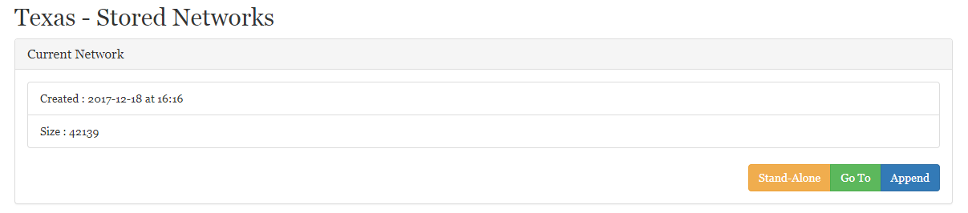
- Click Select Sequence File
- Use the File Explorer to navigate and open the CSV file created in program 1.
  - P:\tis\MHS\Cluster Analysis\HIV Trace\Output\ TX_HIVTRACE_input_YYYYMMDD.csv
- A Warning screen will appear, indicating cases that are missing or have concerning pieces of data. Scan through the list. Most common errors are in the Race_cat or VL_Recent_value fields.
  - Race_cat- errors here are typically that a person has multiple races and this confuses the algorithm. These errors can be ignored
  - VL_recent_value- this error indicates that a person does not have a value in eHARS associated with their most recent viral load date. This error can be typically be ignored.
- Click Ignore and Continue
- Secure HIV Trace will send you an email when the process is complete, or you can check back after about an hour.
- When the append process is complete, you should see a screen with many grey circles.
- Navigate to the Statistics tab and click on the TN93 Distance File to download the TN93.csv file.
- Navigate to the Nodes tab and click on the blue arrow to download the Nodes.csv
- Move the Nodes.csv and TN93.csv files from the Downloads folder (C:\Users\amonterosso520\Downloads) to the HIV TRACE Output folder (P:\tis\MHS\Cluster Analysis\HIV Trace\TRACE outputs).
- Open the SAS Program P:\tis\MHS\Cluster Analysis\HIV Trace\2. MHS_HIV_Trace_cluster_summary.sas
- Change the macro variable DSMASTER to the dataset created in program one and stored in step 4 above.
  - %let DSMASTER=TX_HIVTRACE_MASTER_YYYYMMDD
- Run the Program and examine the log for errors.
- Navigate to P:\tis\MHS\Cluster Analysis\HIV Trace\Program 2 output and locate the latest file version of TX_Cluster_summary_stats_YYYYMMDD_005.csv and open the file
- Column C is the number of people diagnosed in this cluster in the past 12 months, filter down the data to include only clusters with 5 or more cases.
- Navigate to the Texas code for main cluster analysis: P:\tis\MHS\Cluster Analysis\SAS code and open the programs 1. Set Up Macros and 6. HIV TRACE realignment.
- Update the macros in Part A for the dataset information.
- Run Program 1. Set Up Macros.sas
- At the top of the SAS Program 6. HIV TRACE realignment.sas, change the cluster IDs to match the clusters with at least 5 cases in the previous 12 months
- Run the code, but stop at the step 2 cut point.
- Look over the Proc Print, which should have the following columns: stateno clustered c005_id c0015_id.
  - Stateno=eHARS stateno for the case
  - Clusterid= Texas Assigned ClusterID for that molecular cluster case
  - C005_id= CDC program assigned clusterID for clusters with 0.5% genetic distance
  - C015_id= Secure HIV Trace assigned clusterID for clusters with 1.5% genetic distance.
- A new case that is added will should have a missing value in the clusterID. If all new cases map to existing clusters, skip to step 30.
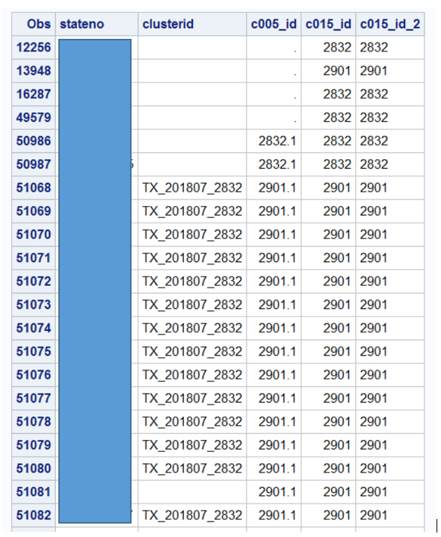
- For any new clusters that are detected and have not already been given a cluster ID, complete the following steps:
  - Create a new macro variable in the Cluster Macros section of the 1. Set Up Macros SAS program with the syntax %let and the name of the cluster will be “TX_YYYYMM_ID” combined with the c015_id. So a cluster with the c015_id= 326 identified in May 2020 will be TX_202005_326. For clusters first identified by CDC, sub the TX for CDC (Ex. CDC_202005_326).
  - Copy all stateno’s for that clusters from the Proc Print to the new %let TX_YYYYMM_ID macro variable you just created. Be sure to enclose all statenos in quotations and separate by a comma. Be sure that there is no comma at the end of the list before the semicolon.
  - Add your new macro variable to the %Active Macro later in the program.
  - Open Program 1b. Molecular Cluster Routine.SAS to add the new cluster and cluster macro to the else-if-then block.
  - Open Program B. THISIS Cluster Link after TNRN.SAS and update the 2 if-then-else blocks with the new cluster information (at the top of the program).
  - Add the new cluster information to the %create_diad() macro block (around the middle of Program B. THISIS Cluster Link after TNRN.SAS).
  - Open and Run Program “Create Import Cluster Tracking CRF.SAS” and import the resulting .txt file in eHARS using the template New ACRF>Cluster Tracking
  - Open and Run Program “Create Import Cluster Tracking Transmission Cluster.SAS” and import the resulting .CSV file into THISIS using the Cluster Tracking Roster Import Processor
- Run all of Program 1. Set Up Macros with the added clusters or cases
- Open the Tableau Workbook: P:\tis\MHS\Cluster Analysis\Confirmed.twb
- Review the page Diagnosis QTR and identify clusters with no growth for the past 12 months. Move those clusters to the Watch macro in program 1. Set Up Macro and remove from the Active macro.
- Save Program 1. Set Up Macros and re-run to update the active and watch macros and Tableau datasets. Run the entire program again.
- Open Program 1B. Molecular Cluster Routine.sas and run all. Check for errors
- Open Program A2. New MC to TNRN Code from THISIS.sas Run all and check for errors
  - Map any external IDS for partners that have been merged since being linked as partners
- Open Program B. THISIS Cluster Link after TNRN.sas Run all and check for errors
- Use the Tableau workbooks in the folder P:\tis\MHS\Cluster Analysis\
  - Confirmed.TWB to review and create snapshots for the Molecular Clusters
  - Active Molecular Clusters.TWB to review and create snapshots for the full molecular clsuters
- Discuss snapshots and other data available with the CDR workgroup
- Work with D2C team to create assignments in THISIS for Data to Care assignments
- Work with PHFU consultants to create assignments for DIS, FHAs or other staff for re-testing and reinterview assignments in THISIS.

