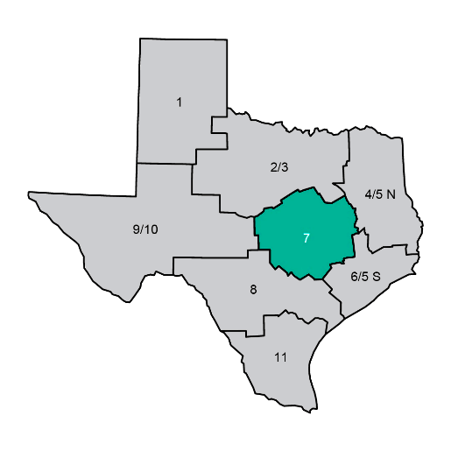
TEXAS DEPARTMENT OF STATE HEALTH SERVICES
Public Health Region 7
Annual Highlights
2022


Bell County (Killeen) | Photographer: Jennifer Hurst
Central Texas | 22 Counties Served | Serving Our Community

dshs.texas.gov/region7

Table of Contents
Public Health By The Numbers 3
Tobacco Prevention & Cessation Success Story 4
COVID-19 5
Mpox Disease Prevention and Treatment Initiative 6
Ebola Monitoring & Capitol Flu Vaccination Clinic 7
Preventing Syphilis = Healthier Newborn 8
Specialized Health and Social Services 9
A Case Management and Investigation System (CMIS) for Public Health Patient Services 10
Electronic Clinical Data Capture and Storage to Enhance Patient Care 11
Preparedness and Epidemiology Program 12
Consumer Health Protection 13
Zoonosis 14
Helpful Contact Information 15

DSHS
Public Health Region 7
22 Counties Served Directly | Additional Counties Served via Local Health Departments
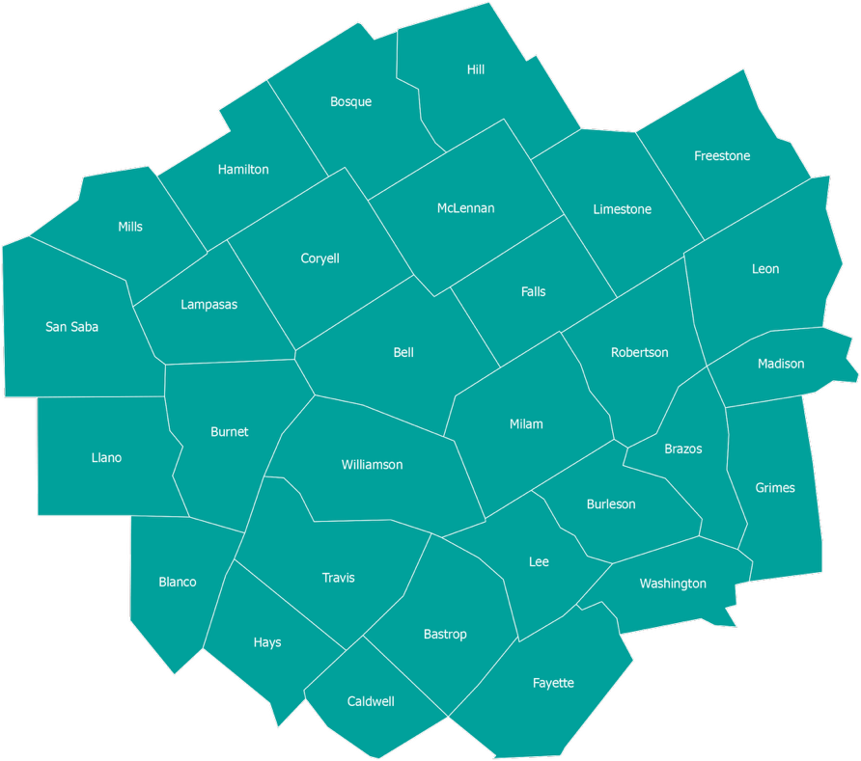

Public Health By The Numbers
Public Health Region 7 | 2022 Annual Highlights | Central Texas
1,512  Retail Food Inspections Conducted | 1,265  Children with Special Needs Served | >443  Forms & Tools Digitized for the Health Record | 326  Community Meetings Attended
288  COVID-19 Vaccine Events Conducted | 4,193  COVID-19 Vaccines Administered | 122  Flu Vaccinations at Capitol Flu Vaccination Clinic | 152  Rabies-Positive Animals Investigated
28  Site Visits to Vaccines for Children & Adult Safety Net Providers | 18  Active Tuberculosis Cases Cared for by DSHS Clinics | 7  Mpox Vaccine Doses Administered | 3  Emergency Responses Supported

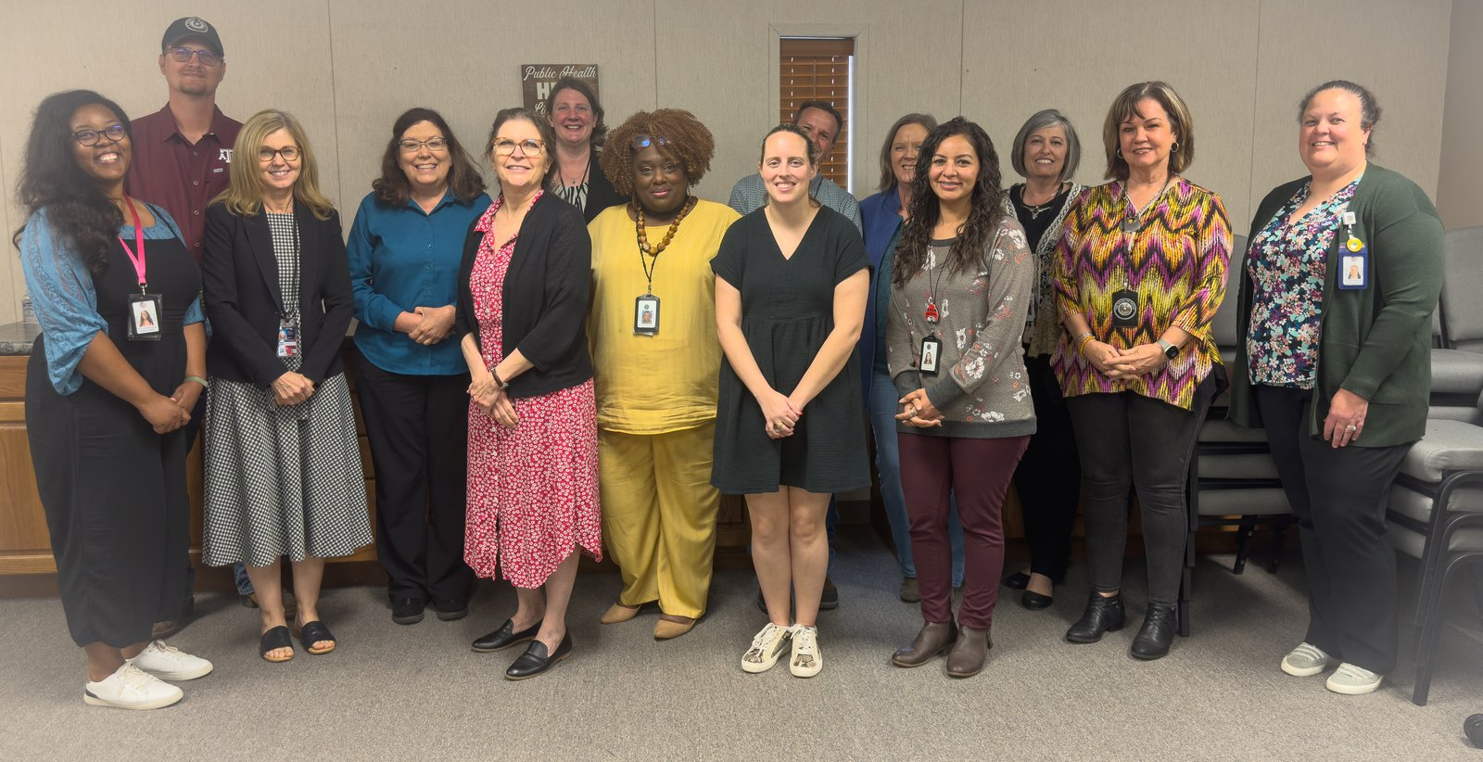

Public Health Region 7 Leadership Team
Tobacco Prevention & Cessation Success Story
3  Consecutive Days of Middle School Workshops | 6  Tobacco Prevention Program Goals | 4  Public Health Outreach & Assessment Objectives

We all remember the fears that gripped the entire world during the pandemic. As we watched the number of deaths rise daily, our children developed fears. Some of our children found themselves alone and sought unhealthy ways to calm their fears. Many of them turned to vaping, creating a cycle of nicotine dependence. But nicotine addiction can also be a source of stress.
The DSHS Region 7 Tobacco Prevention and Control staff member facilitated tobacco prevention workshops at a small Independent School District where she served on the School Health Advisory Council for several years. This year was a bit different. The school’s principal was concerned about many of her middle schoolers using ELECTRONIC NICOTINE DEVICES on campus. The Tobacco Prevention Coordinator was both energized and motivated after spending three consecutive days speaking to the entire middle school about addictions, the dangers of tobacco use, and how sometimes we will search for things outside ourselves to seemingly make us feel better. She spoke about how easy it is to make one bad decision; the one bad decision could change the trajectory of their lives. This workshop reminded her again of the importance of her job and the jobs of other DSHS Tobacco Prevention and Control staff members who’ve been tasked with teaching and advocating public health and the importance of behavior change! The Tobacco Prevention Coordinator was also reminded of just how many schools are facing these real problems. She felt like the middle schoolers heard her. There was one student who sat up front during class and answered lots of the Tobacco Prevention Coordinator’s questions while asking her own questions. The Tobacco Prevention Coordinator asked the class, “What behavior(s) could change the course of your life, if not changed?”. This same student answered, “FIGHTING”. Well, she had to think fast. The Tobacco Prevention Coordinator responded, “You are great at speaking and getting your point across, so use your words and not your fist”. The teachers and even the students thanked her for the words and information presented. There is much more work to do surrounding this subject matter. The Tobacco Prevention and Cessation Program aim is to reduce the toll of tobacco on the health, safety, and well-being of Texans.
Tobacco Prevention & Cessation Program Goals:
- To keep young Texans from starting tobacco use
- Support enforcement of tobacco laws
- Helping more Texans to quit smoking and stay smoke-free
- Eliminate exposure to secondhand smoke
- Reduce tobacco use among high-risk populations
- Develop and maintain statewide capacity to support all the above

The Public Health Assessment and Outreach Program Area was established within PHR 7 during the COVID-19 Pandemic to:
- Assist all program areas with outreach and health education needs within PHR 7 communities.
- Assist regional programs with effectively communicating public health messaging, materials, and supporting documents for communities and stakeholders.
- Support program areas with research to enhance the knowledge of public health concepts through data collection, dissemination, analysis, and recommendations for implementation.
- Help reduce tobacco use within PHR 7 communities.
COVID-19
288  COVID-19 Vaccine Events Conducted | 4,193  Vaccine Doses Administered | 30  County Area Reached

The year started off with a bang regarding COVID-19 where we saw peak cases related to the Omicron variants that second week in January 2022. Omicron was found to spread more easily than the original SARS-CoV-2 strain and the Delta variant. Though it spread more easily, the severity of the disease was found to be lower than that of the previously seen strains. With the increase in cases, there was a concern over whether the COVID-19 vaccines would protect against this new variant. It was shown that if individuals were up to date on their vaccine, they would have some protection against the new variant. This resulted in a quick decrease in cases following the initial increase seen in January. As the year went on, Texas began seeing new sub-variants of Omicron pop up including BA.4 and BA.5 leading to a spike in cases in the summer. As a result, a new bi-valent vaccine became available that combined proteins found in the original COVID-19 strain as well as those found in the new variants. Following the updated booster, we began to see a decrease in cases once again. 2022 continued to see a variety of new Omicron sub-variants, but with the updated booster and no increase in the severity of the disease, we continued to see a low number of cases, hospitalizations, and deaths.
In late 2020, Public Health Region (PHR) 7 began administering COVID-19 vaccinations to help reduce the incidence of serious illness and death from the SARS-CoV-2 virus. This major vaccine initiative continued into 2022. Regional public health activities broadened to reach all age groups and populations at risk for COVID-19 illness. PHR 7 continued to include a focus on the protection of individuals at the highest risk of hospitalization, such as persons residing in a congregate setting and those with immune system challenges.

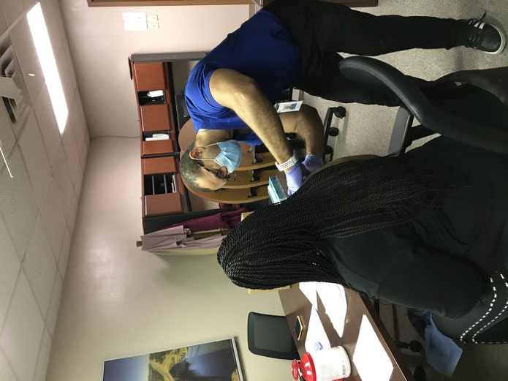

Staff being vaccinated at our first COVID-19 clinic.
Vaccines were available to all age groups based on current Centers for Disease Control and Prevention (CDC) recommendations. Using regional public health nursing and immunization program staff, along with contracted providers and in collaboration with local partners, vaccine events were held across the 30-county area, including large cities, towns, and very rural communities. To reach as many patients as possible, vaccinators worked at long-term care and assisted living facilities; in-home/homebound settings; food/clothing banks; child foster care facilities; housing authorities; community fairs and festivals; local school districts, special campuses, and universities; TXDOT highway rest stops; faith-based events; civic and community centers; farmer’s markets and private businesses. Regional employee and family COVID-19 vaccination clinics were also held throughout the year to protect our team.
Over the course of 2022, two-hundred eighty-eight (288) COVID-19 events were provided by PHR 7. A total of 4,193 vaccination doses were administered to infants, young children, adolescents, and adults. This large-scale effort to support the ability of PHR 7 residents to remain healthy and be able to work, travel, attend school, and enjoy social activities was a major public health success.
Mpox Disease Prevention and Treatment Initiative
3,107  Texas Mpox Cases Reported in 2022 | 7  PHR 7 Vaccine Doses Administered | 1  IND Treatment Protocol Completed

On May 18, 2022, the Centers for Disease Control and Prevention (CDC) reported the first U.S. case of “monkeypox” virus, now referred to as “mpox” virus. Mpox is a viral disease that can spread between people or between people and certain animals. Mpox can spread to anyone through close contact of any kind. Spread often occurs with skin-to-skin contact, including direct contact with mpox rash and scabs from a person with mpox, as well as contact with their saliva, upper respiratory secretions, and areas around the anus, rectum, or vagina. Most mpox cases in the current outbreak have occurred among men who have sex with men and have been transmitted by sexual or other intimate contact. Gay or bisexual men who have recently had multiple or anonymous sexual partners are at the highest risk of getting mpox. A disproportionate number of cases were among Black and Hispanic or Latino men. In Texas, a total of 3,107 cases of mpox were reported in 2022. The first confirmed death in Texas caused by mpox infection was reported in August 2022; the individual was an adult who was severely immunocompromised.
At this same time, the PHR 7 Regional Medical Director approved for clinical staff to vaccinate to help prevent mpox infection and support individuals, including those susceptible to very severe disease, to avoid serious illness or death. As part of this effort, nursing and social services team members conducted telephone outreach to previous patients considered to be at increased risk for mpox infection to encourage “pre-exposure” preventive vaccination. Based upon contacting at-risk individuals and screening new patients for risk of mpox infection, vaccination efforts were offered at PHR 7 public health clinics. Patients were instructed to contact a clinic in their area for an appointment. Licensed nurses were trained on use of this vaccine, originally developed and approved to prevent smallpox infection, and found to be effective against mpox.
In 2022, seven doses of mpox vaccine were administered by PHR 7 clinical staff to prevent mpox infection in higher risk individuals. In cases where it was necessary to meet patient need, such as a person with limited transportation or other significant challenges to receiving vaccine, clinical staff offered a home visit to vaccinate. These preventive efforts were in addition to mpox vaccine doses administered by local health departments and other healthcare providers to PHR 7 residents.
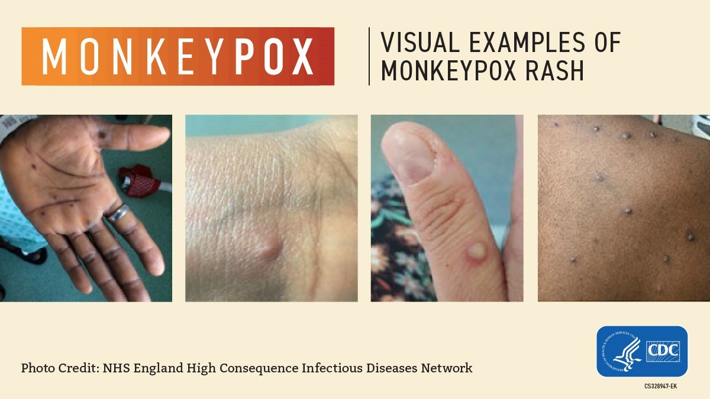
In August 2022, PHR 7 was asked to provide mpox treatment for one rural resident that did not have an eligible treating provider. Tecovirimat, an antiviral medication, was approved in 2018 as treatment for human orthopox viruses such as smallpox; it was not yet approved for treatment of mpox. The patient qualified to participate in an Investigational New Drug (IND) protocol “Expanded Access IND Protocol: Use of Tecovirimat (TPOXX) for treatment of Human Non-Variola Orthopoxvirus Infections in Adults and Children.” The patient completed oral treatment with resolution of mpox symptoms and no adverse effects. Clinical assessment and patient subjective data were shared with the CDC at initiation, during and following treatment. The epidemiology, preparedness, administration, and public health nursing programs were involved in coordination of care and IND protocols.

Photo Credit: NHS England High Consequence Infectious Diseases Network / CDC

Ebola Monitoring & Capitol Flu Vaccination Clinic
EBOLA MONITORING
On September 20, 2022, the Ugandan Ministry of Health confirmed an outbreak of Ebola (Sudan virus) in the Mubende District of Uganda. The outbreak then spread to nine districts within the southern and western parts of Uganda. As seen in previous Ebola outbreaks, the CDC recommended conducting risk assessments and monitoring of all travelers who had recently visited Uganda. Travelers who had visited Uganda were routed through specific airports across the US to be screened and gather their information so that their local health department can conduct the risk assessment and monitoring activities.
Based on DSHS Central Office guidance, travelers were monitored based on their risk category of either high risk, some risk, low risk or no identifiable risk. High-risk individuals were those who had direct contact with someone with known or suspected Ebola Virus Disease (EVD) without proper personal protection equipment (PPE). Some risk included those who were in contact with a known or suspected EVD case but with no breach in PPE. Low risk were those individuals who traveled to a designated Ebola outbreak area but had no other identified exposures. No identifiable risk was those who traveled to Uganda, but who were not in one of the districts with a known EVD case.
All travelers were contacted within 24 hours of the notification from the CDC. Upon contact, the PHR 7 Epidemiology team conducted the risk assessment to determine the traveler’s risk level. The traveler was asked if they had any symptoms, and their temperature was recorded.

Region 7 received four notifications of travelers who were in an Ebola outbreak area. Of those, three were contacted and monitored and one was lost to follow-up. The three contacts we were able to get in contact with were considered low-risk, were contacted twice a week, and were contacted on their final monitoring day. None became symptomatic. On January 11, 2023, Uganda’s Ministry of Health declared the end of the Ebola outbreak which signaled the end of monitoring of travelers.

CAPITOL FLU VACCINATION CLINIC
On Thursday, October 20, 2022, a special PHR 7 team
traveled to the Texas State Capitol building to provide
the “Capitol Flu Vaccination Clinic.” Legislators and their staff,
along with Texas Department of Public Safety officers assigned
to duty at this location, were offered the opportunity to receive
annual influenza vaccinations at their worksite. Community
vaccination events are “standard practice” for public health teams.
The special clinic, however, affords law makers an opportunity
to remain healthy and working during the legislative session.
Many PHR 7 staff rose very early in the morning to transport
vaccine supplies which require special handling, and/or traveled
long distances to participate. Several staff volunteered to substitute
for others unable to participate as planned. Patients were screened
to ensure the flu vaccine was appropriate for each person and monitored
afterwards to prevent potential complications. One person experienced
a rare but non-serious reaction and was referred to the on-site advanced
practice nurse for evaluation. One hundred twenty-two (122) people
were vaccinated to prevent influenza. In addition, three legislative staff
also received a COVID-19 booster vaccine dose to prevent serious illness
as the pandemic was slowing but disease cases were still being reported
regularly. The day was a public health success.
Texas State House in Austin | Photographer: RozenskiP/Shutterstock
Preventing Syphilis = Healthier Newborn
Great things happen every day in public health, but there are certain days that just stand out. In early March 2022, a PHR 7 Disease Intervention Specialist (DIS) was in the HIV/STD program regional headquarters office. DIS are public health team members who investigate cases of sexually transmitted infections (STIs) to conduct follow-up activities, identify individuals at risk for becoming infected with an STI, and promote STI testing and linkage to medical treatment when needed. The DIS was discussing a pregnant woman recently diagnosed with syphilis with the HIV/STD program manager. Syphilis can be transmitted from the mother to an unborn baby and cause serious and/or fatal outcomes for the fetus.
The pregnant woman, who was incarcerated in a local jail, previously received two of three required antibiotic injections to prevent disease in the baby. The DIS shared the patient had just been discharged from jail the previous day and before receiving the third injection which was due immediately. If the injections were not completed on a strict timeline, the injections were to be started over. The DIS was unsure if she could locate the woman as she had no working phone number; she planned to travel to her last known residence the next day.
Congenital Syphilis Prevention
Timely antibiotic treatment on a strict schedule is essential to prevent transmission of syphilis from mother to baby. A missed or delayed dose can require the full injection series to restart.


The HIV/STD program manager quickly coordinated with a PHR 7 public health nurse who planned to make herself available to provide the third antibiotic injection that afternoon if the patient could be found. The DIS was able to locate the patient quickly and convince her to go immediately to the clinic for treatment. Rapid action by the DIS and the willingness of the public health nurse to change her schedule on a moment’s notice to administer the medication allowed the antibiotic series to be completed. This avoided the need to restart injections. This PHR 7 team’s “can do” attitude meant the newborn would have the best chance for a healthy birth and a life free from disease.

Photographer: Vad-Len/Shutterstock
Specialized Health and Social Services
The Specialized Health and Social Services (SHSS) Program provides services which include:
- In-home comprehensive Case Management by licensed social workers for children with special needs ages 0 to 21 years. Currently we serve 352 children and their families.
- Individual assessments conducted for Personal Care Services (PCS) and Community First Choice (CFC) attendant care-benefits of Medicaid. Currently serving 90 families for PCS and CFC.
- Children With Special Health Care Needs (CSHCN-SP) Insurance application assistance and eligibility determination. Ongoing caseload of 210+ families.
- Texas Health Steps Representatives provide regular contact, education, training and support to 2,436 Medical and Dental providers in Region 7 (1,604 Medical and 832 Dental).
Some additional Infrastructure Grants allowed us to include Behavioral Health coordination and services and an Information and Referral Specialist for adults and children across all 30 counties of our DSHS Region 7. In 2023, we received 470 new intakes for information, referral and active services depending upon the needs of the clients.
352  Children Served | 90  Families (PCS/CFC) | 210+  CSHCN-SP Caseload | 470  New Intakes

In the SHSS Program, our licensed social workers work with a variety of families, most of whom have children with special health care needs. One family stands out as a great success story with a happy ending. It all started for the boy we will call Edwardo. When he was just eight years old and living with his parents in El Salvador, he was injured in a motorcycle accident. He suffered a severely broken jaw and there were little doctors could do at that time to repair the jaw. As it healed, Edwardo had difficulty eating and talking. At some point, Edwardo’s family chose to bring him to the United States to try and seek better medical care for their son. Fast forward to many years later and Edwardo’s family put their son on a waiting list for the CSHCN (Children with Special Health Care Needs) insurance program. A PHR 7 licensed social worker was assigned the case. Eventually Edwardo was pulled from the waiting list, and parents were told he could receive active services. He was referred to a maxillofacial surgeon. The family was so excited about the possibility of Edwardo having a new jaw, however this proved to be a very complex situation. Even though the surgeon agreed to donate his surgical skills to perform the surgery, that alone was not enough. For this type of jaw replacement to occur, it required all the doctors, hospitals and parties involved to first become a Medicaid provider and then a CSHCN provider. The jaw had to be manufactured from a specialized company who also had to become a provider. This process involved some great work and persistence on the part of our social worker, who could have easily given up. But rather the PHR 7 licensed social worker continued to seek out help from many medical community partners including Texas Medicaid Health Partnership (TMHP) to obtain all the many necessary layers of approvals and steps to make this happen.
It took over 1½ years to get through the entire process. Edwardo had turned 15 years old, and his father told the PHR 7 licensed social worker that his son would pray every night that the PHR 7 licensed social worker could help him get his new jaw. At one point Edwardo started talking about not wanting to live any longer in that condition, as he suffered bullying and ridicule because of his abnormal jaw and difficulty with speech. Finally, the PHR 7 licensed social worker was able to get the jaw replacement approved by getting all the parties involved to talk weekly in order to obtain the necessary authorizations. In April 2023, the surgery finally occurred even though the PHR 7 licensed social worker received a call the night before the surgery from TMHP stating that the approvals had expired due to delays in building the jaw and it almost didn’t happen with last minute clerical errors on the authorization request. The PHR 7 licensed social worker did some troubleshooting, and the surgery did occur. The biggest smile you can imagine was the result and Edwardo could finally go into the world looking again like a “typical” 15-year-old. Although we all (in our SHSS program) celebrated the PHR 7 licensed social worker and his amazing patience and determination in working this case, the only thanks that he really needed was that boy’s smile and knowing that this job was finally complete with a very happy ending. The persistence and dedication to this young boy is amazing and exemplifies DSHS values in helping our clients get the services they need, no matter the obstacles or if an extended time commitment is necessary.

A Case Management and Investigation System (CMIS) for Public Health Patient Services
≥26  Workflow Documents Developed | 132+  Workflow Versions Analyzed | 80+  Project Workgroup Meetings Attended | >443  Forms & Tools Digitized

Since 2014, Texas Department of State Health Services leadership has pursued an electronic health record, or “EHR.” An EHR supports agency goals, including improvement in business practices and the availability of data upon which to base patient care decisions. When COVID-19 hit Texas in 2020, Regional and Local Health Operations (RLHO) prioritized services by envisioning all patient medical records in a central system to allow disease investigation and patient referral to critical services. In 2021 when CMIS project monies were secured, regional staff across the state undertook research of critical EHR functions, such as the ability to capture patient vaccination data for the new COVID-19 vaccines.
In November 2021, a CMIS Oversight Panel convened to provide input into proposed CMIS workflows. A workflow process is a set of steps or tasks that are followed to complete a specific process or job within an organization. It defines the sequence of activities, who is responsible for each task, and what tools or resources are required to complete it. Public Health Region 7 program staff attended weekly panel meetings. Staff were charged with coordinating across regions and with other agency stakeholders to create operational workflows and documentation to be integrated into the CMIS. They also joined regular project “office hours” to resolve detailed technical issues. Since March 2022, an additional team effort also analyzed proposed workflows to identify required and recommended CMIS “forms” to be created, and established data reports to support leadership decision-making.
The Public Health Region 7 team developed and edited at least 26 workflow documents, analyzing more than 132 total workflow versions. Team members attended at least 80 project workgroup meetings and other focused meetings. More than 443 forms and tools were provided to the technical team to create electronic versions in the health record; most forms were sourced from regional program staff. They also recommended key product functions and features critical to CMIS success.
In July 2022, the “Case Management and Investigation System” (CMIS) proposal to select a vendor was published by Texas Health and Human Services. The requirements for a case management and investigation system proposal include many regional staff recommendations. Since that time, a CMIS vendor has been selected, and the contract negotiation process is moving forward. The stellar Public Health Region 7 team contributions to this effort will be a key factor to successfully achieving the DSHS strategic goals tied to this system. Anticipated next steps for regional involvement are the identification of CMIS super-users, establishment of work groups to guide regional implementation at the program level, and staff training.


Photographer: Tero Vesalainen/Shutterstock
Electronic Clinical Data Capture and Storage to Enhance Patient Care
Prior to the Case Management and Investigation System (CMIS) project moving forward, all documentation of direct patient services, such as nursing care delivered to persons with tuberculosis, or TB, the disease was captured on paper forms and stored in a file cabinet in the clinic where the individual was treated. Information was not routinely accessible to other public health staff assisting with patient care. An electronic system, referred to as “THISIS”, was also in use to capture certain TB and sexually transmitted infection (STI) non-clinical, and some clinical, data.
In 2019, Public Health Region 7 staff members conceptualized a system to allow certain staff and the Regional Medical Director to use the regional electronic “share drive” to confidentially communicate clinical information and make medical treatment decisions in a more efficient manner. This Public Health Region 7 innovation is referred to as “Bridge to THISIS”, or “BTT.” During the 2020-2023 COVID-19 pandemic response, BTT allowed clinical staff working in remote settings to share patient care documents electronically which otherwise would require a physical trip by the team to communicate the information.
Public Health Region 7 BTT clinical patient data entry for TB has moved to a pdf format, and most recently STI clinical data is also being created as a pdf. This moves patient information away from paper as much as possible. The use of BTT serves to better prepare the regional team for a successful transition to the coming DSHS electronic health record.


Photographer: Have a nice day Photo/Shutterstock

The concept of capturing and storing clinical data information has expanded to public health nursing clinics regarding STI/HIV encounters. An “encounter” is basically an interaction or service delivery to an individual. Clinical STI/HIV encounters are available in the recently created STD Awareness System (SAS). The concept of localized document storage has reduced treatment delays previously experienced due to a lack of timely access to accurate and/or complete patient information. This concept also promotes environmental preservation as less paper is used to document and transmit data to healthcare providers.
As a supplement to the localized data storage, the region has customized an encounter tool that captures program-specific public health nursing activities. Clinic staff now reconcile their daily work activities into an electronic survey, enabling visualization by management of services offered in each regional clinic. This data was initially developed to assess STI/HIV services within Public Health Region 7 locations. The data was used to identify the feasibility of implementing a program to offer medications to at-risk individuals to prevent HIV infection. It was expanded to detect and preventively treat at-risk patients during the 2022 mpox outbreak. The tool is now gathering information to capture Public Health Region 7 public health nursing community outreach, TB, STI/HIV, immunization, zoonosis, pertussis (“whooping cough”), case management, and preparedness encounters.
Preparedness and Epidemiology Program
Reported Disease Case Counts in Texas DSHS PHR 7
Disease | 2020 | 2021 | 2022
Campylobacteriosis | 167 | 179 | 110
Carbapenem-Resistant Enterobacteriaceae (CRE) | 2 | 6 | 11
Cryptosporidiosis | 15 | 14 | 15
Cyclosporiasis | 15 | 2 | 13
Haemophilus influenzae, invasive | 6 | 8 | 18
Hepatitis A, acute | 0 | 1 | 1
Hepatitis B, acute | 2 | 0 | 1
Legionellosis | 6 | 9 | 12
Neisseria meningitidis | 0 | 0 | 1
Pertussis | 13 | 2 | 2
Salmonellosis | 167 | 171 | 210
Shiga toxin-producing Escherichia coli (STEC) | 34 | 26 | 40
Shigellosis | 40 | 9 | 15
Streptococcus pneumoniae, invasive disease (IPD) | 43 | 44 | 51
Varicella (Chickenpox) | 16 | 5 | 6
Yersiniosis | 9 | 10 | 13
Totals | 535 | 486 | 519
Cases include Texas Notifiable conditions reported to the DSHS PHR 7 Epidemiology Program and entered in NEDSS during MMWR Years 2020–2022.

Total Number of Reportable Disease Cases in DSHS PHR 7 by Year
2020
  535
2021
  486
2022
  519

Consumer Health Protection
The Consumer Health Protection Program Manager discovered a mobile food unit operating without any running water available, not once, not twice, but 3 times in a row in less than a month. Region 7 Sanitarians then performed the follow-up inspection at the Central Preparation Facility, where it was learned that the firm was not using the facility at all. This again caused the firm to fail the inspection, and the Voluntary Closure was not lifted on the establishment. At this point it was evident that the firm was not operating with food safety at the forefront despite multiple attempts to educate and train ownership and staff. It became apparent that compliance was no longer a feasible option. The case was sent to our enforcement commission where the owners were given the option of paying a large fine or agreeing to cease operation immediately and voluntarily agree to have their license revoked. The owners elected the license revocation hence garnering improved food safety for the community in and near Burleson County.
Throughout this process, we worked closely with city officials as well as Burleson County Code Enforcement as they also had active cases related to environmental concerns with this mobile unit. The partnerships here fast-tracked our ability to reduce the risk to the public. All of this took place over about 90 days totaling 6 different inspections, one in-person meeting in Austin, one conference call with mobile food unit owners, numerous internal meetings, phone calls, emails, warning letters, Notice of Violation (NOV) letters, as well as multiple discussions with DSHS General Counsel on the process along the way.
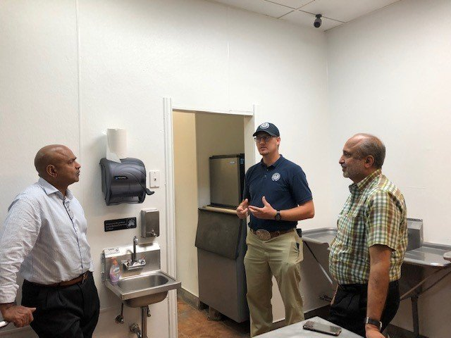

The Consumer Health Protection Program Manager educating about food safety

Zoonosis
Rabies is a fatal but preventable viral disease. It can spread to people and pets if they are bitten or scratched by a rabid animal. The rabies virus infects the central nervous system. If a person does not receive the appropriate medical care after a potential rabies exposure, the virus can cause disease in the brain, ultimately resulting in death. Rabies can be prevented by vaccinating pets, staying away from wildlife, and seeking medical care after potential exposures before symptoms start.
In 2022, the PHR 7 Zoonosis Control Program staff responded daily to events in which an individual(s) may have been exposed to rabies. Examples of the impact of their work to prevent rabies illness and death include:
- The team explains the dangers of a rabid bat found inside a home so a decision to receive rabies postexposure prophylaxis (PEP) can be made by those in the house. A family was unsure about their risk after spending the night at a relative’s house where a rabid bat was found. Their primary care doctor did not think they were at risk for being exposed to rabies because they did not recall any contact with the bat. However, the bedroom door was open while they slept. CDC expert guidance advises this situation puts individuals in danger of rabies exposure since they cannot “reasonably exclude the possibility of a bite.” After consultation with the PHR 7 Zoonosis Control program, the couple could not be reasonably certain that they were not exposed to the bat. They made the decision to pursue rabies postexposure prophylaxis to prevent rabies disease.
- The PHR 7 Zoonosis Control Program conducted a rabies case investigation involving multiple puppies taken in by an animal rescue for care, and eventually to two different veterinary facilities for illness. Most of the puppies were subsequently confirmed to be infected with rabies through testing at the DSHS Rabies laboratory. The investigation involved several different organizations who had contact with the puppies. During the public health investigation, twenty-four persons were identified who may have had contact with these rabid puppies. The Zoonosis Control Program interviewed and provided guidance to the individuals and organizations when rabies exposures may have occurred. They helped ensure potentially exposed persons were provided with the public health information about rabies risk, postexposure prophylaxis, rabies symptoms in animals, and steps to help prevent the transmission of rabies in the future.
SUMMARY OF ANIMAL RABIES CASES
152  Positive Animals Investigated | 78  Non-Negative Animals Investigated | 124  People Exposed | 228  Animals Exposed

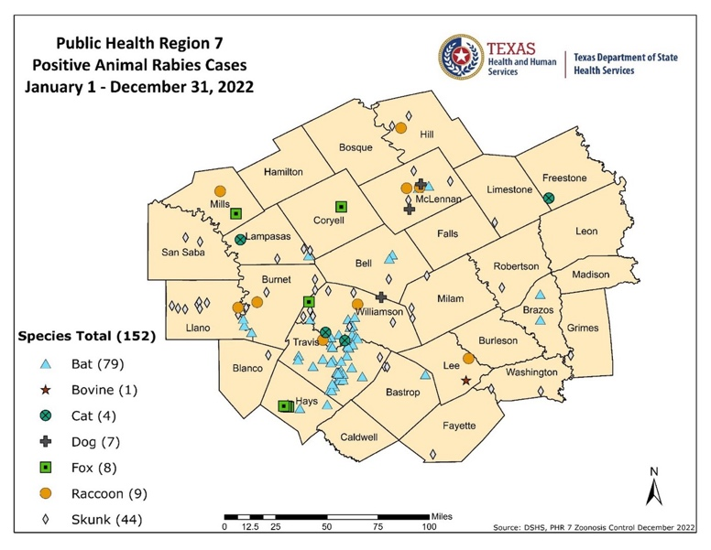
Between January and December 2022, there were 152 laboratory-confirmed rabies positive animals investigated by Public Health Region 7 Zoonosis Control Program. Public Health Region 7 also conducted case investigations into 78 non-negative animals whose rabies tests were reported as either “decomposed” or “destroyed”. One hundred and twenty-four people and 228 animals were exposed or potentially exposed to these positive and non-negative animals.

*Map displays cases based
on longitude and latitude
coordinates. Because some
counties’ cases occurred near
each other, some individual map
symbols may not be distinguishable.
PHR 7  Public Health Region 7  REGIONAL MEDICAL DIRECTOR  Sharon K. Melville, MD, MPH  sharon.melville@dshs.texas.gov  DEPUTY REGIONAL DIRECTOR  Carol M. Davis, DrPH, MSPH, CPH  carol.davis@dshs.texas.gov  HEADQUARTERS  1010 Old Waco Road  Temple, Texas 76502  Phone: 254.778.6744  Fax: 254.778.4066  dshs.texas.gov/region7 | Helpful Contact Information  Texas Department of State Health Services | Public Health Region 7 | 2022
  Program | Manager | E-mail Address
  Birth Defects | Dawn Surnick | dawn.surnick@dshs.texas.gov
  Infectious Disease Prevention | Johnathan Ledbetter | johnathan.ledbetter@dshs.texas.gov
  Consumer Health Protection | Donald Jirasek | foodestablishments@dshs.texas.gov
  Immunization | Debbie Shelton | debbie.shelton@dshs.texas.gov
  Preparedness/Epidemiology | Bonnie Morehead | bonnie.morehead@dshs.texas.gov
  Public Health Assessment & Outreach | Francesca Austin Campbell | francesca.campbell@dshs.texas.gov
  Family & Community Health | Shelby Hyde  Sharon Torres | shelby.hyde@dshs.texas.gov  sharon.torres@dshs.texas.gov
  Specialized Health & Social Services | Alicia Lopez | alicia.lopez@dshs.texas.gov
  HIV/STD | Aaron Kelly | aaron.kelly@dshs.texas.gov
  Tuberculosis | Bonnie Gamez | bonnie.gamez@dshs.texas.gov
  Vision & Hearing | Paul Gonzalez | paul.gonzalez@dshs.texas.gov
  Zoonosis | David Smonko, DVM | david.smonko@dshs.texas.gov

DSHS Central Texas • Public Health Region 7 Serving You • dshs.texas.gov/region7

