
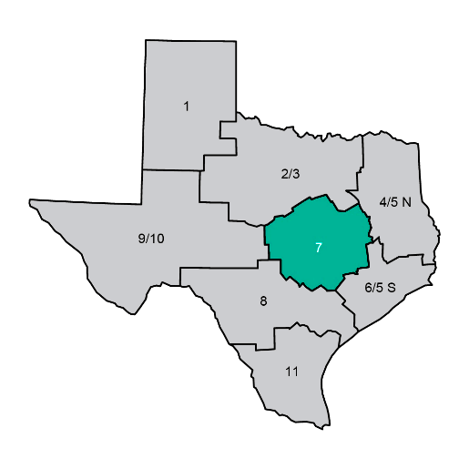
dshs.texas.gov/phr7
TEXAS DEPARTMENT OF STATE HEALTH SERVICES
Public Health Region 7
Annual Highlights
2025

Central Texas | 30 Counties | Serving Our Community
Table of Contents
Public Health By The Numbers 3
Let’s Talk – Safe Infant Sleep 4
Public Health Region 7 Supports Bell County’s Tuberculosis Program, 2024–2025 5
New Headquarters Building for PHR 7 6
The Role and Impact of the LVN/Disease Intervention Specialist in the HIV/STD Program 7
Tuberculosis Lunch and Learns with Private Providers 8
Typhoid Fever: School Exclusion and Re-Admission Case Study 9
Flooding in Central Texas – July 2025 10
2025 PHR 7 Measles Response 11
Substantial Increase in Community Outreach – PHR 7 West Side Counties 12
Region 7 Leadership Visits All Regional Clinics 13
​​Helpful Contact Information 14
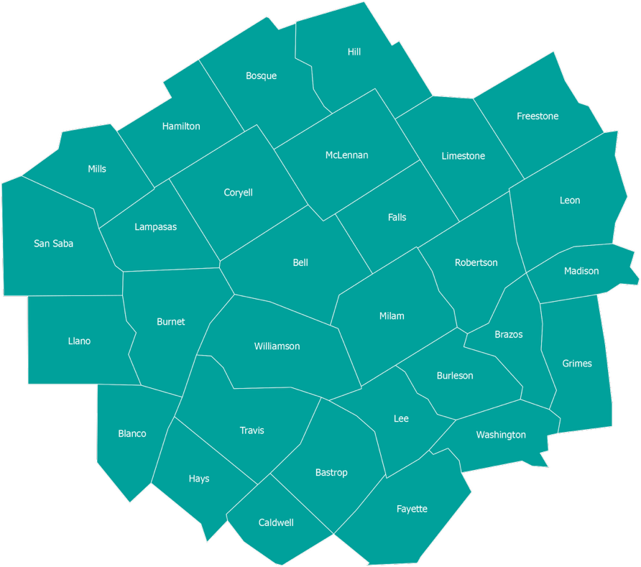
DSHS
Public Health Region 7
30 Counties
Public Health By The Numbers
Public Health Region 7 | 2025 Annual Highlights | Central Texas
6,063  Patients Served  in PHR 7 Clinics | 3,466  Vaccine Doses  Administered | 1,734  Youths (ages 11–17)  Educated on Tobacco Harms | 1,188  Adults (ages 25+)  Educated on Tobacco Harms
1,110  Texas Health Steps  Visits to Medicaid Providers | 1,009  Children with Special Health  Care Needs Served | >450  Community Meetings  & Events Attended | 202  Immunization Provider  Visits Completed¹
169  Rabies-Positive Animal  Exposures Investigated | 271  Young Adults (ages 18–24)  Educated on Tobacco Harms | 125  Active Tuberculosis  Cases Identified | 115  Flu Vaccinations at  Capitol Flu Clinic, Austin
14  Active TB Patients Received  Direct Clinic Care³ | 3  Emergency Responses  Supported in 2025 | 54  School & Childcare  Vaccination Audits² | 30  Counties Served Across  Central Texas
HIV/STD Program
1,096  New Syphilis  Morbidity Cases | 159  New HIV Cases⁴ | 17  Congenital Syphilis  Confirmed/Probable | 133  Partners Receiving  Preventive Treatment
Epidemiology Program
1,144
Confirmed & Probable Cases Investigated Across 22 Reportable Conditions⁵
Texas Department of State Health Services | dshs.texas.gov/region7
1 A provider visit is conducted by the PHR 7 Immunization Team. It includes offering technical assistance, checking provider status, and addressing any issues, if needed.
2 Immunization record audits are conducted on assigned K-12 schools, childcare, and registered family homes by requesting de-identified records to determine the immunization rate of these facilities.
3 This number reflects the patients with active TB disease who received clinical care by PHR 7’s Nursing staff.
4 These numbers reflect the case counts investigated by the HIV/STD Public Health Region 7 team. Numbers are subject to change.
5 Cases represent confirmed and probable cases investigated by Public Health Region 7 in 2025 and are subject to change.
Let’s Talk – Safe Infant Sleep
by Shelby Hyde, MSN
On January 19, 2025, nine Region 7 Nursing Program staff partnered with the Healthy Women and Children Coalition to participate in a “Train the Trainer” Let’s Talk – Safe Infant Sleep course in Waco, Texas. The course equipped participants with the knowledge to train new “trainers” who would, in turn, educate caregivers of newborns on creating safe sleeping environments.
On April 15, 2025, after completing the training, the nine new trainers provided the safe sleep education to the remaining Region 7 Nursing Program staff. To support community outreach, all staff were provided with Cribs for Kids equipment — including a small crib, infant doll, crib accessories, and a training toolkit containing group activity instructions and participant reference materials.
Following this training initiative, more than 100 infant caregivers across Central Texas received practical strategies to ensure infants are placed in safe sleeping environments. The ultimate goal of this program is the prevention of infant injury and death.
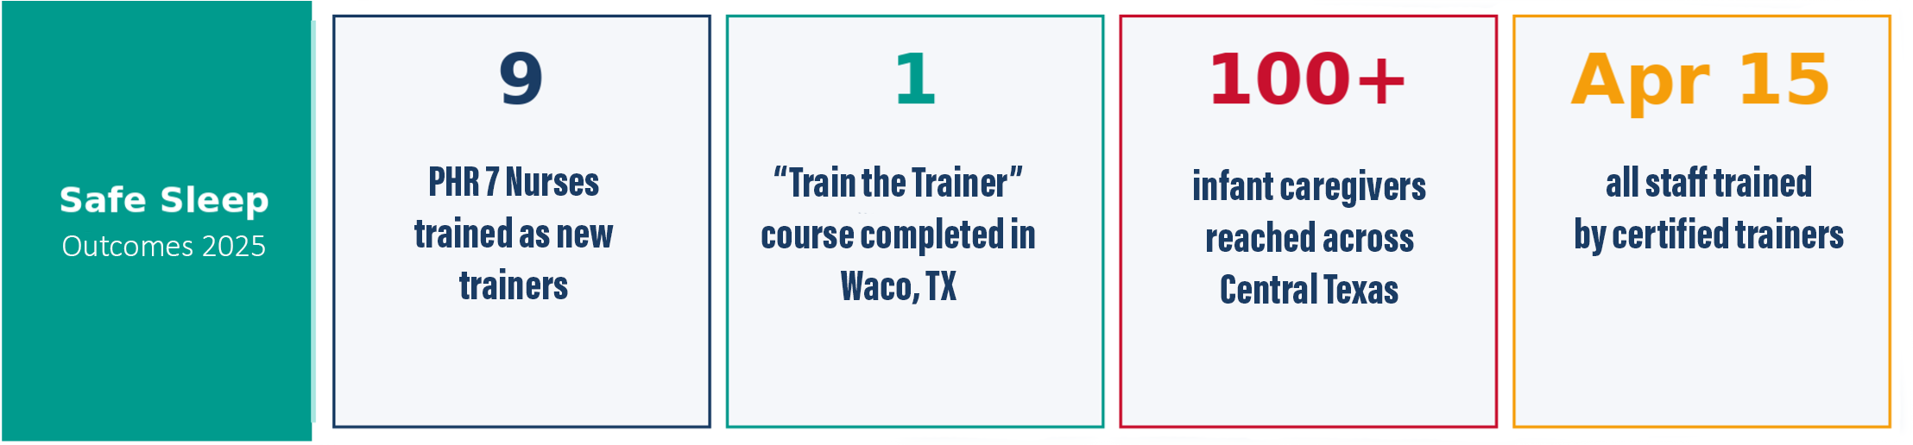



Public Health Region 7 Supports Bell County’s Tuberculosis Program, 2024–2025
by Bonnie Gamez, BSN, RN, CIC and Mary Menix, APRN-FNP
PHR 7 recently completed a yearlong project with the DSHS Tuberculosis and Hansen’s Disease Unit to help the Bell County Public Health District (BCPHD) rebuild its TB program — a collaboration that was unique because local health departments typically manage TB programs without direct support from regional offices.
BACKGROUND
In September 2024, PHR 7 increased support after the Bell County Local Health Authority/Medical Director resigned and the health department faced serious staffing shortages. Without a supervising physician, staff could not legally provide medical care. PHR 7 nurses assumed patient care under Dr. Sharon K. Melville’s leadership, ensuring that patients diagnosed with TB could continue their Directly Observed Therapy (DOT) — a strict treatment protocol requiring daily observation by a health worker.
REBUILDING THE PROGRAM
Regional nurse leaders from surrounding PHR 7 counties visited Bell County patients in their homes while simultaneously training BCPHD staff to resume program management. A long-term rebuilding plan was established with expert support from the state. PHR 7 also managed the official patient tracking database throughout the transition.
As the patient caseload grew, PHR 7 spent four months developing a formal agreement between DSHS and BCPHD that allowed PHR 7 staff to use Bell County’s clinic facilities beginning in February 2025. This agreement also enabled the hiring of a contract nurse and medical assistant.
OUTCOMES
Over the course of the year, the PHR 7 regional nurse leader team cared for nine patients with active TB disease and four high-risk patients with TB infection, while also investigating several exposure cases and completing more than 20 medical evaluations for immigrants.
On September 1, 2025, BCPHD successfully resumed TB patient care with their new staff and Medical Director, Dr. Jesse Hickland. PHR 7 continued to manage the database through December 31, 2025, with ongoing education and technical assistance. This partnership ensured community safety throughout the transition to independent operation.
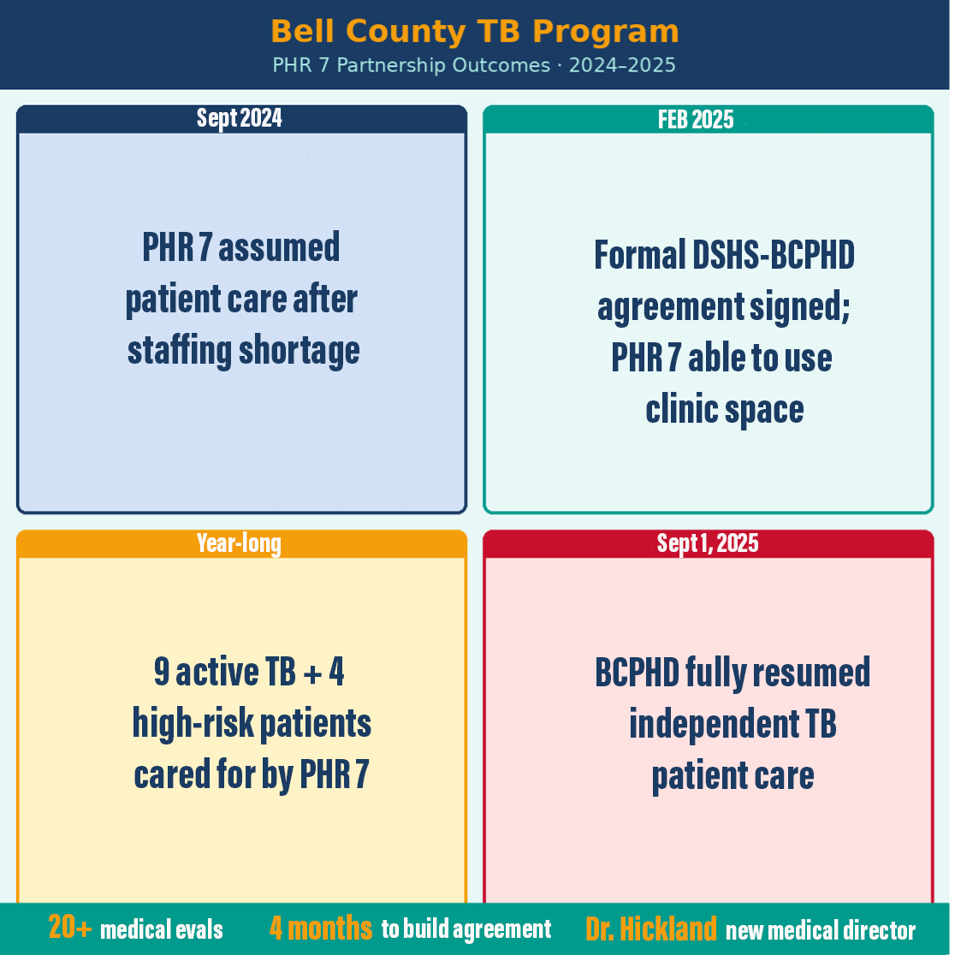

New Headquarters Building for PHR 7
by Carol Davis, DrPH, MSPH, CPH
Public Health Region 7 has been headquartered on 37th Street in Temple, Texas, for more than 30 years. In 2021, DSHS and the Health and Human Services Commission jointly decided to identify a new building as the existing facility had been outgrown. The need for a new building became urgent in 2024 when a series of severe weather events caused a leaky roof and widespread water damage throughout the building. The facility was closed, and employees worked remotely for most of 2024, all of 2025 and part of 2026.
In January 2025, ground broke on a new building on Old Waco Road in Temple. The new building has been completed and employees moved into the building on May 1, 2026. At over 5,000 square feet larger than the original facility — which was approximately 23,000 square feet — the new building represents a significant upgrade for PHR 7 operations.
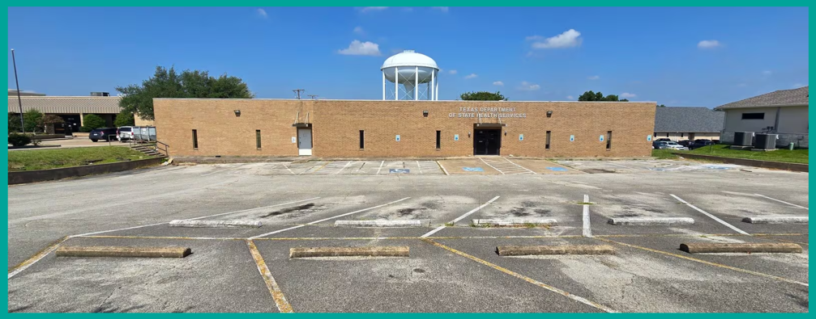
The new headquarters will include an additional training room, a new clinical space, and extra warehouse space. As the anchor for public health operations across 30 counties, the building will support more than 80 employees based in Temple, whose work routinely involves traveling throughout the region to conduct inspections, home visits, partner meetings, and other field-based public health activities.

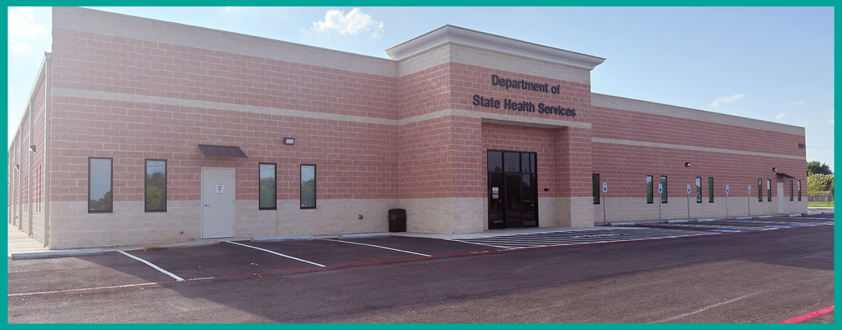

The Role and Impact of the LVN/Disease Intervention Specialist in the HIV/STD Program
by Mary Menix, APRN-FNP and Aaron Kelly, HIV/STD Program Manager
PHR 7 participates in a statewide DSHS initiative to decrease the spread of syphilis and congenital syphilis. The HIV/STD Program identified a gap in services for patients facing challenges — particularly related to transportation and access to care. Before 2025, Disease Intervention Specialist (DIS) staff frequently encountered obstacles coordinating treatment due to these barriers.
To address this, a Licensed Vocational Nurse (LVN)/DIS position was established within the HIV/STD program. This role provides in-home assessments and treatments by licensed personnel, including physical assessments, medication administration, and linkage to supplemental resources such as prenatal care and substance abuse counseling. In 2025, the LVN/DIS provided direct medical care to more than 13 medically at-risk syphilis clients in addition to routine DIS duties.
CASE STUDY: IDENTIFYING NEUROSYPHILIS
A compelling example of this role's impact occurred when LVN/DIS Lea Lopez identified signs and symptoms of neurologic syphilis during a routine partner services interview. The client reported a one-to-two-month history of vision changes, ringing in the ears, and hair loss — all potential indicators of neurological involvement. Neurosyphilis occurs when syphilis spreads to the brain, spinal cord, or surrounding tissues.
Ms. Lopez advised the client to seek care at a local emergency department. After coordination across multiple facilities, PHR 7 staff ultimately worked with the Veterans Affairs (VA) infectious disease physician in Temple, where the patient was admitted for 14 days, fully evaluated, diagnosed, and given appropriate intravenous treatment for neurosyphilis. The patient expressed gratitude for everyone involved, stating he knew he did not feel well but that no one had previously taken his symptoms seriously.
This case highlights the collaborative efforts of Lea Lopez, LVN/DIS; Aaron Kelly, HIV/STD Program Manager; and Mary Menix, APRN-FNP — a team committed to ensuring patients receive proper medical treatment. Looking ahead, the LVN/ DIS role will expand screening to include chlamydia and gonorrhea in the coming year.
Neurosyphilis: Key Points
Neurosyphilis can occur at any stage of infection and requires intravenous antibiotic therapy. Left untreated, it can cause seizures, dementia, hearing loss, vision loss, and death.


3d rendering of Treponema pallidum, the bacteria that cause syphilis.

Tuberculosis Lunch and Learns with Private Providers
by Mary Menix, APRN-FNP
In support of the Texas Tuberculosis Manual’s standards for maintaining robust program infrastructure, PHR 7 developed a Tuberculosis Lunch and Learn presentation titled “Tuberculosis Awareness in the Family Practice and Specialty Setting” for medical providers working outside the public health system.
The presentation provides geographically specific TB epidemiologic information, case counts, incidence data, U.S. Preventive Services Task Force (USPSTF) recommendations, reporting requirements, and TB screening and treatment guidelines tailored to providers and patients within PHR 7. Launched in July 2025, the program is independently solicited and coordinated by PHR 7 staff.
As of November 15, 2025, six clinics within the Baylor Scott and White, Coryell Health, and Health Point systems hosted PHR 7 Public Health Nursing and TB staff, reaching 48 providers. The response has been widely positive, with strong willingness to implement USPSTF screening recommendations. One practice administrator even requested PHR 7 follow-up guidance to develop a workflow for routine screening of at-risk clients.
These sessions give providers a localized snapshot of how tuberculosis impacts their community and introduces them to PHR 7 Public Health Nursing Program staff — helping to build lasting relationships and raise awareness of local, regional, and state TB resources.

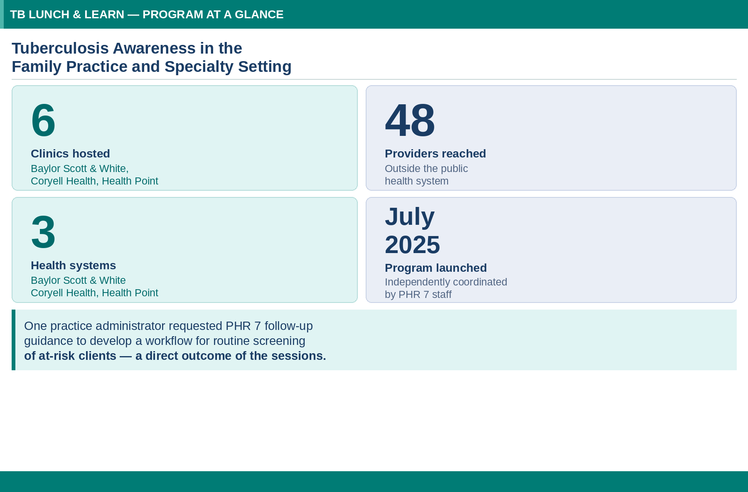

Typhoid Fever: School Exclusion and Re-Admission Case Study
by Kyle Kimmey, MPH, CIC, CPH
A school-aged child was diagnosed with typhoid fever following recent international travel. The initial presentation included fever, abdominal pain, chills, and diarrhea. Diagnosis was confirmed through clinical examination and microbiological culture. Despite completing an appropriate antibiotic regimen with documented clinical response, post-treatment follow-up stool cultures remained positive for Salmonella Typhi even after the patient became asymptomatic.
This situation created a challenge under Texas state regulations (Texas Administrative Code (TAC) Title 25, Part 1, Chapter 97, Subchapter A, §97.7), which generally requires three negative stool cultures before readmitting a child diagnosed with typhoid fever to school. The persistence of positive cultures over several months — despite the child being symptom-free — required a thoughtful public health response.
RESOLUTION
The case was resolved through a physician evaluation under TAC option 1, which allows a physician’s clinical judgment to override strict laboratory criteria when deemed appropriate. An infectious disease specialist assessed the patient and concluded the child did not pose a transmission risk, supporting readmission to school despite positive stool cultures.

Acknowledgements: PHR 7 gratefully acknowledges the contributions of Kaleb Fowlkes, Asha Saraswate, and Dr. Amanda Norwood (Williamson County and Cities Health District); Conner Kelly, Arnold Martinez, and Bonnie Morehead (DSHS PHR 7); Dr. Mehgan Kidd (DSHS Office of Chief State Epidemiologist); Irina Cody and Kenneth Davis (DSHS Emerging and Acute Infectious Disease Unit); and Texas Children’s Hospital.

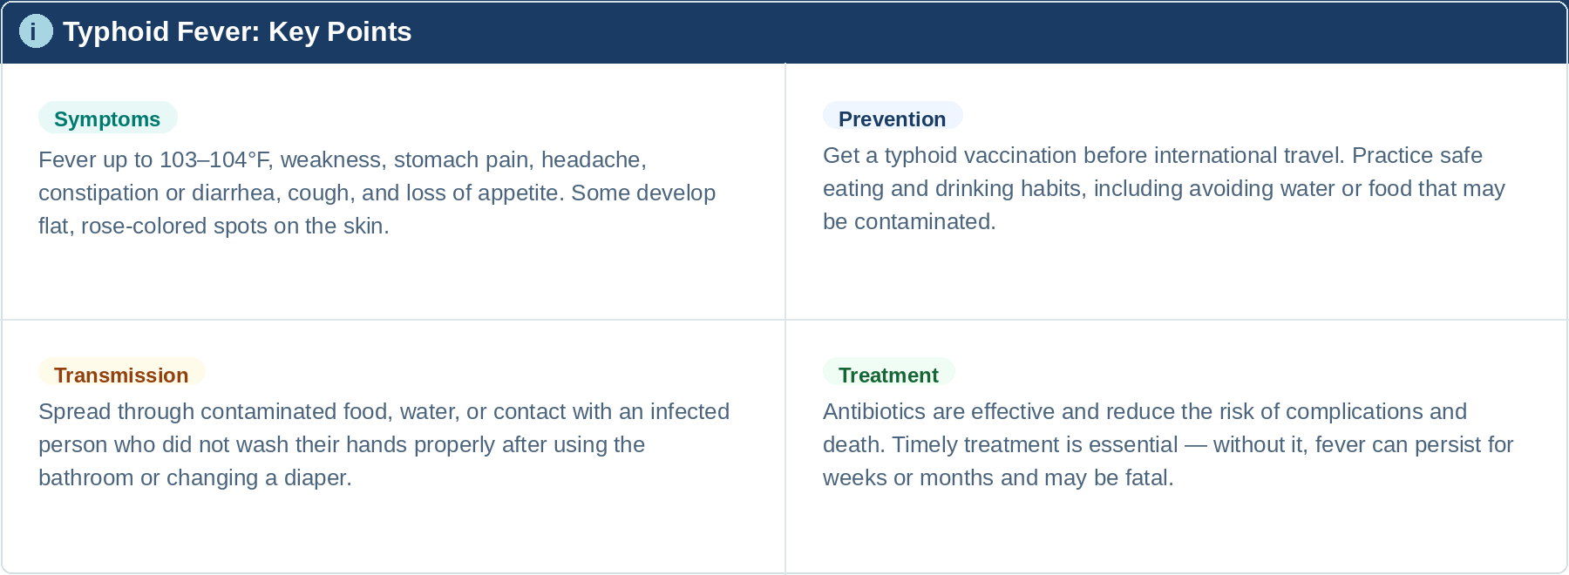

Flooding in Central Texas – July 2025
by Julia Butler and Bonnie Morehead
Before the severe weather that struck over the July 4, 2025, holiday weekend, the PHR 7 Preparedness and Epidemiology team was already maintaining situational awareness — attending state weather calls and standing by to provide Emergency Support Function-8 (ESF-8) Public Health and Medical Services support. The event brought heavy rainfall and subsequent flash flooding to multiple PHR 7 counties, posing significant risks to public health and safety.
On July 4, Governor Gregg Abbott issued a State Disaster Declaration for 21 Texas counties. Six additional counties were added on July 5. The PHR 7 counties affected included Hamilton, Llano, San Saba, Burnet, Caldwell, Travis, and Williamson.
RESPONSE OPERATIONS
PHR 7 has five disaster districts that enhance preparedness and response: District 11 (Waco), District 12 (Austin), District 13 (Bryan), District 23 (Killeen), and Capitol District 25 (Austin). The Disaster District Emergency Operations Center 12 (DDEOC 12) was activated in Williamson County. PHR 7 deployed a team member to fill the ESF-8 chair in person on July 5 and 6, communicating with PHR 7 leadership, the State Medical Operations Center (SMOC), emergency management partners, local health departments, and hospital preparedness program representatives.
RESPONSE ACTIVITIES
- Providing Critical Incident Stress Management (CISM) processes
- Distributing local mental health authority contact information
- Coordinating discussions on vaccine and immunization clinics
- Conducting Community Assessment for Public Health Emergency Response (CASPER) discussions
- Surveillance for injury and illnesses associated with the incident
- Conducting food safety consultations in Burnet, San Saba, Lampasas, and Llano Counties

By July 14, the Consumer Health Protection Program had assessed the need for and conducted food consultations in four counties. The Preparedness and Epidemiology team was also notified of a San Saba County nursing home evacuation and maintained ongoing support for affected communities.
Between July 15–24, PHR 7 continued to monitor the situation, responding to DDEOC 12 (Austin) and DDEOC 23 (Killeen) inquiries and supporting recovery efforts. Vital records assistance was coordinated for Burnet County residents. DDEOC 23 returned to normal operations on July 16; DDEOC 12 on July 23; and PHR 7’s Regional Public Health and Medical Operations Center (RPHMOC) deactivated and returned to normal operations on July 25, 2025.
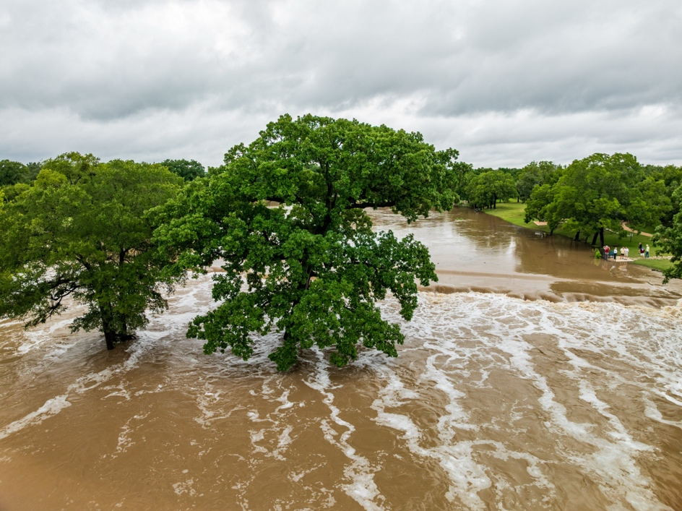

Aerial view of flooding in Georgetown

Texas after heavy rainfall in July 2025
2025 PHR 7 Measles Response
by Bonnie Morehead, Conner Kelly, Julia Butler, Kyle Kimmey, and Elizabeth Hans
At the peak of the 2025 Texas Measles Outbreak, regional and central office staff were asked to volunteer for 10-day deployments to Public Health Region 1 to relieve personnel who had been responding since the outbreak’s beginning. Several PHR 7 Preparedness and Epidemiology team members deployed from March through May 2025, filling critical roles including Incident Commander, Operations Section Chief, Lead Epidemiologist, Deputy Operations Section Chief, and Epidemiologist.
STATEWIDE SUPPORT & CASE INVESTIGATION SYSTEM
One significant contribution during the deployment was PHR 7 Lead Epidemiologist, Conner Kelly’s development of a Qualtrics form allowing regional staff statewide to sign up for and conduct measles case investigations remotely — eliminating the need for in-person deployment for many volunteers while building investigation capacity across the state. A dedicated training was created to standardize the process, focusing on exposures, close contacts, and travel history.
DATA QUALITY & DASHBOARD DEVELOPMENT
With a large and rapidly growing outbreak dataset, rigorous data quality efforts were essential. PHR 7 epidemiologists performed daily checks to identify and correct missing, duplicate, or incongruent data entries in the Microsoft Excel-based dataset. Specific patient identification numbers were added to enable investigators to quickly locate cases in the Texas National Electronic Disease Surveillance System (NEDSS). Assigning fresh-eyed volunteers to this task improved overall data quality and freed investigators for active case interviews.
To support regional outbreak management, PHR 7 also developed a real-time Measles Dashboard using Microsoft Excel — accessible to regional leadership and featuring county-level testing data stratified by test type (IgG, IgM, RT-PCR), case investigation status, rash onset dates, and aggregated case counts.
PHR 7 LOCAL RESPONSE
While much of the state response was centered in other regions, PHR 7 also investigated local cases. The region identified 18 confirmed cases, 3 suspect cases, and 69 reports that were investigated but ruled out. Response activities integrated clinical assessment, laboratory testing, provider education, and data management.
Case stratification guided public health actions: low-risk cases (documented MMR vaccination, no travel, alternate diagnosis) required standard isolation, while high-risk cases (unvaccinated, known exposure, recent travel) required enhanced isolation, immunity verification for exposed staff, and potential environmental controls including air handler assessments and temporary facility closures.
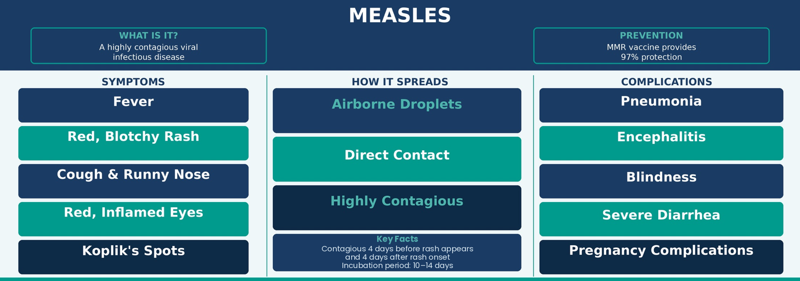
Provider education was delivered both in-person and virtually across PHR 7 healthcare facilities, emphasizing adherence to testing protocols and the preference for RT-PCR in suspected acute cases. PHR 7 also recommended adding an Intelligence Section to the response organizational chart — a contribution that enhanced situational awareness throughout the outbreak. All PHRs gained valuable experience and forged new relationships through this collaborative statewide response.

Substantial Increase in Community Outreach – PHR 7 West Side Counties
by Shelby Hyde, MSN
In 2025, the newest members of the Nursing Program — Stacey Calabro, RN; Tammy Pastor, Community Health Specialist; Dee Edwards, RN; and Barbara Blake, RN — significantly increased DSHS’s presence in the region’s West Side counties through outreach events including off-site immunization clinics, car seat safety events, and community health fairs.
Due to previous staffing challenges and the absence of clinic facilities in several West side counties, these areas historically had fewer interactions with Region 7 Nursing Program staff than other parts of the region. The 2025 efforts represented a meaningful step toward closing that gap.
IMPACT HIGHLIGHTS
- More than 150 children received vaccinations through school, church, and community events — many of whom were behind on immunizations and unable to attend school.
- 27 car seat safety checks were performed; 16 new car seats were distributed and 8 unsafe seats discarded.
- At National Night Out events in Gatesville and Lampasas (500+ attendees), DSHS staff distributed pamphlets and public health information to the community.

COMMUNITY PARTNERSHIPS & COMMITTEES
West side staff serve as active contributing members of the following community organizations:
- Hill Country Child Fatality Review Team (CFRT)
- CenTX CFRT
- San Saba Community Resource Coordination Group (CRCG)
- Mills County CRCG
- Lampasas Lighthouse Pregnancy and Family Center
- Hamilton County CRCG
- Blanco County CRCG
- Llano County CRCG
- Lampasas County No One Left Behind
- Coryell County CRCG
- Llano Emergency Planning Committee

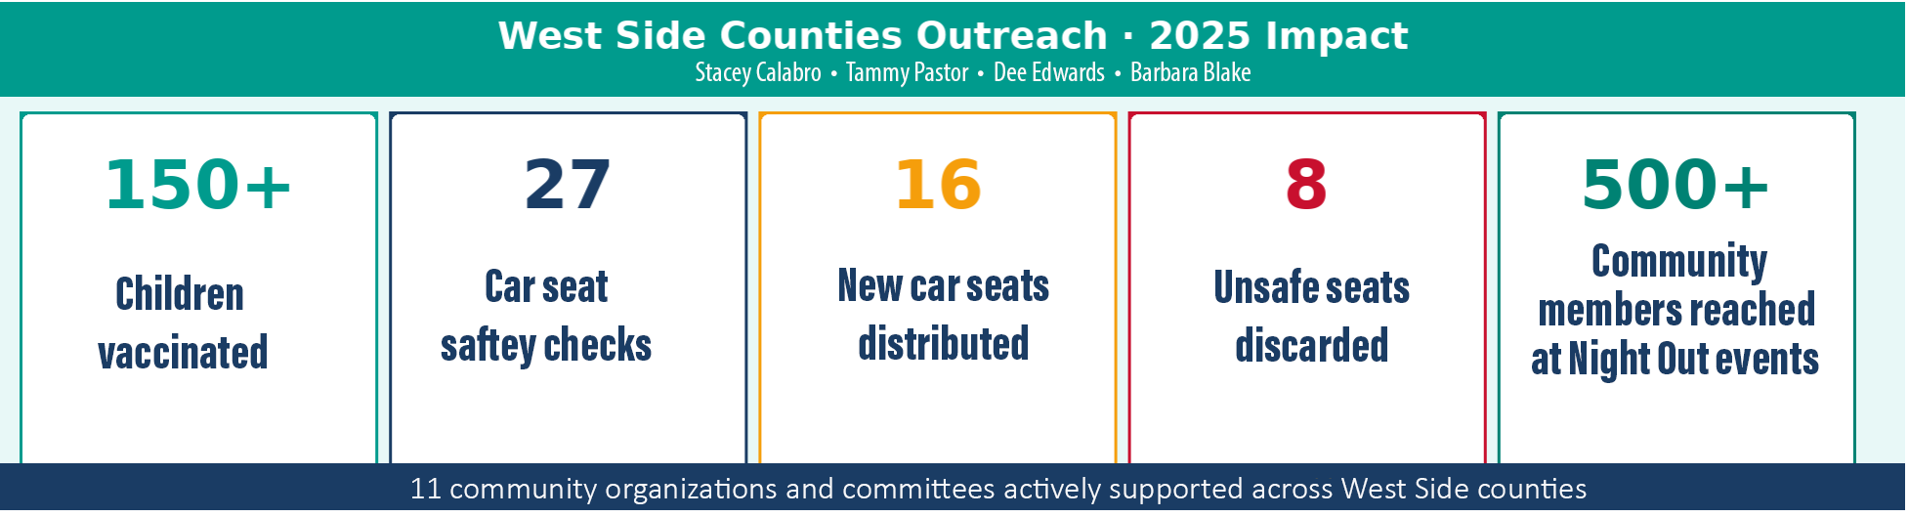

Region 7 Leadership Visits All Regional Clinics
by Shelby Hyde, MSN
Between January 27 and April 16, 2025, Dr. Melville (PHR 7 Regional Medical Director) and Johnathan Ledbetter (PHR 7 Infectious Disease Prevention Manager) visited all 17 regional clinics. Dr. Melville asked staff about their communities and clinics, the successes they experienced, and the challenges they faced.
Dr. Melville and Johnathan visited with staff over lunch, sharing personal and professional information and experiences, and devoted their attention to learning more about each team member. The time regional leadership invested in traveling to every clinic and meeting with nursing program staff in an informal, genuine manner cultivated positive and productive relationships across the region.
Nursing program staff appreciated the connection with regional leadership and expressed gratitude for the sincere interest Dr. Melville and Johnathan have shown in them and the work they do every day.

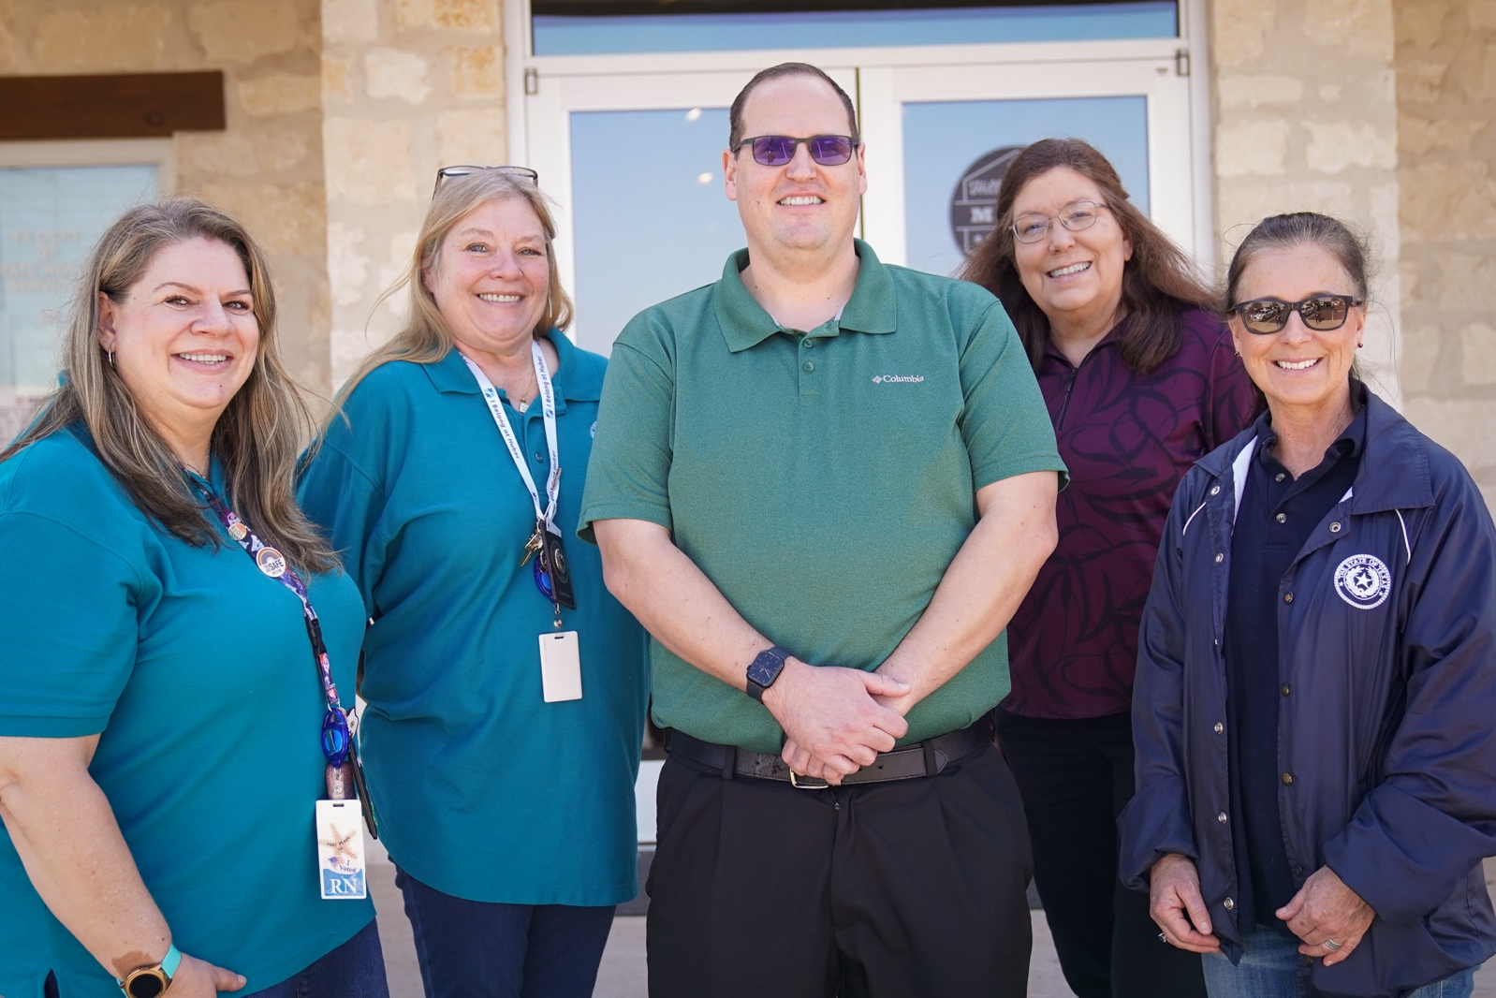

Pictured left to right: Stacey Calabro (Public Health Nurse), Tammy Pastor (Community Health Specialist), Johnathan Ledbetter (Infectious Disease Prevention Manager), Dr. Sharon Melville (Regional Medical Director), and Shelby Hyde (Public Health Nursing & Community Health Improvement Manager) at the PHR7 clinic in Llano.

PHR 7  Public Health Region 7  REGIONAL MEDICAL DIRECTOR  Sharon K. Melville, MD, MPH  sharon.melville@dshs.texas.gov  DEPUTY REGIONAL DIRECTOR  Carol M. Davis, DrPH, MSPH, CPH  carol.davis@dshs.texas.gov  HEADQUARTERS  1010 Old Waco Road  Temple, Texas 76502  Phone: 254.771.6744  Fax: 254.778.4066  dshs.texas.gov/region7 | Helpful Contact Information  Texas Department of State Health Services | Public Health Region 7 | 2025
  Program | Manager | E-mail Address
  Birth Defects | Dawn Surnick | dawn.surnick@dshs.texas.gov
  Infectious Disease Prevention | Johnathan Ledbetter | johnathan.ledbetter@dshs.texas.gov
  Consumer Health Protection | Donald Jirasek | foodestablishments@dshs.texas.gov
  Immunization | Debbie Shelton | debbie.shelton@dshs.texas.gov
  Preparedness/Epidemiology | Bonnie Morehead | bonnie.morehead@dshs.texas.gov
  Public Health Assessment & Outreach | Francesca Austin Campbell | francesca.campbell@dshs.texas.gov
  Public Health Nursing & Community Health Improvement | Shelby Hyde / Sharon Torres | shelby.hyde@dshs.texas.gov / sharon.torres@dshs.texas.gov
  Specialized Health & Social Services | Alicia Lopez | alicia.lopez@dshs.texas.gov
  HIV/STD | Aaron Kelly | aaron.kelly@dshs.texas.gov
  Tuberculosis | Bonnie Gamez | bonnie.gamez@dshs.texas.gov
  Vision & Hearing | Paul Gonzalez | paul.gonzalez@dshs.texas.gov
  Zoonosis | David Smonko, DVM | david.smonko@dshs.texas.gov

DSHS Central Texas • Public Health Region 7 Serving You • dshs.texas.gov/region7

